FastGAPP v2.0

Manual & Documentation

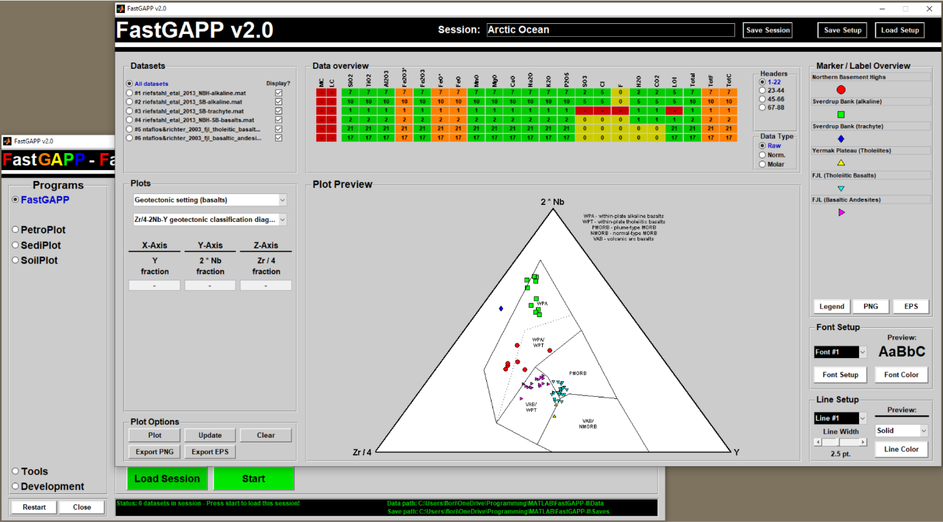

By Florian Riefstahl

with contributions of Felix Gross

Title image: Graphical user interface of FastGAPP. Geochemical data from the Yermak Plateau (Riefstahl et al., 2013) and Franz Josef Land (Ntaflos and Richter, 2003) are plotted in the ternary 2Nb-Zr/4-Y diagram after Meschede (1986).

**”The whole is greater than the sum of its parts.”**

**- Aristotle**

Contents

1. Introduction 1

1.1 The idea behind FastGAPP 1

1.2 What is new? 2

2. Installation and starting FastGAPP 3

2.1 System, software, and hardware requirements 3

Operating system 3

Software 3

Hardware 3

2.2 Installation of FastGAPP 3

2.3 Starting MATLAB 3

2.4 Starting FastGAPP 3

3. First steps with FastGAPP 5

3.1 Program selection 5

3.2 The general structure of an input dataset 5

3.3 Tools - Changing save and data paths 6

3.4 Tools - Converting spreadsheets (.xls/.xlsx) into MATLAB (.mat) files 8

How to start and use of the ‘Convert 2 MAT’ tool 8

Developer notes - Additional information on the mat-file format for FastGAPP 9

3.5 Dataset selection 9

Further information 10

3.6 Loading a session 10

3.7 Starting the session and data processing 12

Further information – Default marker / labels and file import 12

Further information - NaN values 13

Further information - Data processing and defaults plot lines and labels 13

Further information - Initialization of the main window and loaded sessions 14

4. General functionality of the main windows 15

4.1 Dataset selection panel 16

4.2 Data overview panel 16

4.3 Marker / Label overview panel 17

4.4 Dataset overview table 18

4.5 Marker / Label setup panel 19

4.6 Font & Line setup panels 20

Further information 20

4.7 Plot selection panel 20

4.8 Plot Options panel, Plot Preview and the Final Plot 21

The Plot Options panel 21

The Plot Preview 22

The final plot 22

4.9 Saving / Loading Markers and Saving Sessions 23

5. FastGAPP v2.0 25

5.1 Supported header values, units and internal storage 25

5.2 Calculations 26

Fe2O3, FeO, Fe2O3 total and FeO total 27

Normalization to 100 wt.% 27

Molar conversion 27

Other calculated parameters 27

5.3 Contained plots 27

5.4 PLOT-O-MAT – Plotting of elemental variation diagrams 29

5.5 MULTIPL – The multi-element plotter 31

6. PetroPlot v2.0 35

6.1 Supported header values, units and internal storage 35

6.2 Calculations 35

P and Plg 36

Cpx, Opx, and Px 36

6.3 Contained plots 36

7. SediPlot v1.0 37

7.1 Supported header values, units and internal storage 37

7.2 Calculations 37

Qt, Qm, and Qp 37

Silt, Clay, and Mud 38

7.3 Contained plots 38

8. SoilPlot v1.0 39

8.1 Supported header values, units and internal storage 39

8.2 Calculations with header entries 39

8.3 Contained plots 39

9. User-defined marker and labels 40

9.1 User-defined markers 40

9.2 User-defined labels 41

10. Other Tools 43

10.1 Chelements & PTE 43

Chelements – Usage and Background 43

PTE – Periodic Table of Elements 44

Further development information 44

10.2 GeoT 45

How to start and use 45

Further information 46

11. How to create a new sub-program 47

11.1 The PlotScriptCreator 47

Prerequisites 47

MATLAB functions created by the PlotScriptCreator 49

How to run the PlotScriptCreator 49

11.2 The ProgramCreator 51

11.3 The NormCreator 52

12. Contact the developer 54

References 55

Acknowledgements 59

# Introduction

Geochemical studies of igneous rocks are fundamental to classify rock types in terms of main-, minor‑, and trace element whole-rock chemistry. Together with petrographic thin section observations Earth scientists classify igneous rocks and draw interpretations about:

* The petrogenesis and evolution of igneous rocks.
* The thermal and barometric conditions in which a primary magma have formed.
* The magmatic processes that might be involved in the evolution of igneous rocks.
* The geotectonic environment in which igneous rocks might have formed.

Specific programs for the evaluation of geochemical data of igneous rocks are rare and difficult to use. Additionally, changing the setup of the created plots and comparison with publicized data are extremely time-intensive, and therefore, expensive and inefficient. **FastGAPP v2.0 (Fast Geoscientific Analysis Plotting Program)**, a user-friendly MATLAB-based program automatically reads geochemical datasets from Excel spreadsheets or mat-files, normalizes the data volatile-free, and allows to plot up to 9 datasets in a quantity of geochemical classification, magma-series and geotectonic discrimination diagrams, which are based on approximately one century of petrological and geochemical research. Several function like the MULTIPLotter and the PLOT-O-MAT integrated in FastGAPP easily allow users to create rare-earth element, multi-element plots and variation diagrams.

FastGAPP v2.0 can also support Earth scientists from other fields. Other integrated programs allow to plot petrographic data from igneous rocks (PetroPlot v2.0), to evaluate compositional and grain size data from sedimentary rocks (SediPlot v1.0), and grain size analyses from (SoilPlot v1.0). Moreover, the development tools included in FastGAPP v2.0 allow scientists without programming skills to enhance the database of normalization values and plots for all programs, but also develop new programs. Therefore, the first version of FastGAPP yields an interesting, very user-friendly base with many applications in research and teaching not only for whole-rock geochemistry and petrography, but also for other fields of Earth Sciences.

## The idea behind FastGAPP

The development of FastGAPP started in 2011 as a master project at the University of Bremen. The developer struggled in his B.Sc. thesis with the time-intensive comparison of some dredged rocks from the Yermak Plateau with literature data around the Arctic Ocean. Performance of the same steps of recalculation for every dataset is very time-consuming, monotonous, and can be error-prone when concentration decreases with time. The idea was born to solve this issue programmatically by creating a graphical user interface, which perform repeating tasks on different datasets. This idea led to the development of FastGAPP v1.0 in the developer’s master project at the University of Bremen. Afterwards, the developer continued improving FastGAPP to make the existing workflows even less time-consuming for developer and for other scientists as well. Functions were created to enable adjustment plots, markers and labels. The performance and functionality of FastGAPP’s code was largely improved and the workflows are simplified, more intuitive, and less time-consuming. Today, FastGAPP v2.0 is more than a simple collection of geochemical plots for igneous rocks. FastGAPP can also plots petrographic data from igneous rocks, sedimentary rocks and grain size analyses of soils. Scientists even have the possibility to enhance the databases of normalization values, plots and contained programs without any programming skills.

## What is new?

Numerous new, extended or improved features are implemented in the new version of FastGAPP.

FastGAPP start-up window:

* new intuitive graphical user interface
* reworked file selection system for up to 9 files
* new tools help users working with FastGAPP

File input:

* support of mat-file input
* automatic import of program-specific headers

Program functionality:

* easy and complete adjustment of plots, labels, and markers
* improved data overview
* easy export of portable network graphics and encapsulates postscripts
* support of multiple instances
* save / load sessions

New program and program updates:

* FastGAPP v2.0
  + more than 50 new plots
  + MULTIPLotter – user-friendly plotting of multi-element diagrams
  + PLOT-O-MAT v2.0 – improved plotting of variation diagrams
* PetroPlot v2.0
  + 15 new plots
* SediPlot v1.0
  + new program helps plotting sedimentary rocks petrography and grain sizes
  + includes 10 different plots
* SoilPlot v1.0
  + new program helps plotting soil grain size analyses
  + includes 1 plot

# Installation and starting FastGAPP

## System, software, and hardware requirements

Operating system

The FastGAPP program works platform-independent. It is possible to run FastGAPP on Windows / UNIX / Macintosh OS X platforms if the software and hardware requirements are achieved.

Software

Running FastGAPP requires any MATLAB version installed on the platform. Since MATLAB is a dynamic programming language, an up-to-date MATLAB version is strongly recommended to be installed on the platform.

To import Excel spreadsheets into FastGAPP an actual version of Microsoft Office (including Microsoft Excel) needs to be installed on the machine.

Hardware

The FastGAPP programs only uses 5 MB on the HDD. Since MATLAB and Microsoft Excel need to be installed, the minimum hardware requirements are:

* Any Intel or AMD x86-64 processor
* 3.1-8 GB of HDD space (SSD recommended)
* 4-8 GB RAM

## Installation of FastGAPP

FastGAPP can be executed from any directory on the platform. Unpack the FASTGAPP20.zip in any directory (e.g., C:\programs\). Congratulations, the installation is finished.

## Starting MATLAB

MATLAB can be started by several ways. If a MATLAB icon exists on the desktop, double-click it to start MATLAB. Another way is to use the platform-specific start menus.

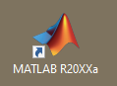Fig. 2.3‑1: MATLAB icon on the Windows desktop. Double-click to start MATLAB.

Dependent on installed MATLAB version and configuration the MATLAB main window opens and usually contains a bar where several options like the current folder are shown as well as several panels (i.e., ‘Current Folder’, ’Command Window’, ’Workspace’, ’Command History’).

## Starting FastGAPP

After MATLAB has been started, it is required to change the current folder to the FastGAPP20 directory. Use the ‘Browse for folder’ icon left of the bar where the current folder is shown. Navigate in the next window to the location where FastGAPP20 folder is located, select the FastGAPP20 folder and confirm by a click on the ‘Select Folder’ button. Now, the current folder has been changed and the contents are shown in the ‘Current Folder’ panel of MATLAB’s main window.

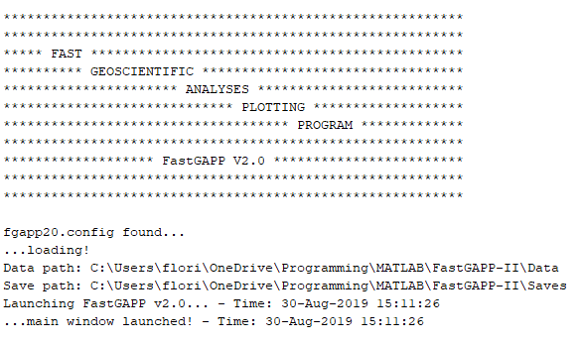Fig. 2.4‑1: Output to the MATLAB command window after starting FastGAPP. The output indicates that the config file fgapp20.config exists in the FastGAPP directory and shows the save and data paths stored therein.

There are different ways to finally start FastGAPP v2.0. (i) Type in ‘FGAPP20’ into the ‘Command Window’ and press enter. (ii) Click in FGAPP20.m in ‘Current Folder’ panel of MATLAB and press F9. (iii) Right-click on the FGAPP20.m in ‘Current Folder’ panel and click on ‘Run’ in the context menu.

Some status output is drawn to the MATLAB command window (Fig. 2.4-1) and a new figure opens. This figure is the main window of FastGAPP (Fig. 2.4-2) and can be used for selection of the sub-programs, datasets to import, tools, and development tools. The functionality of the FastGAPP main window is step-by-step explained in section 3.

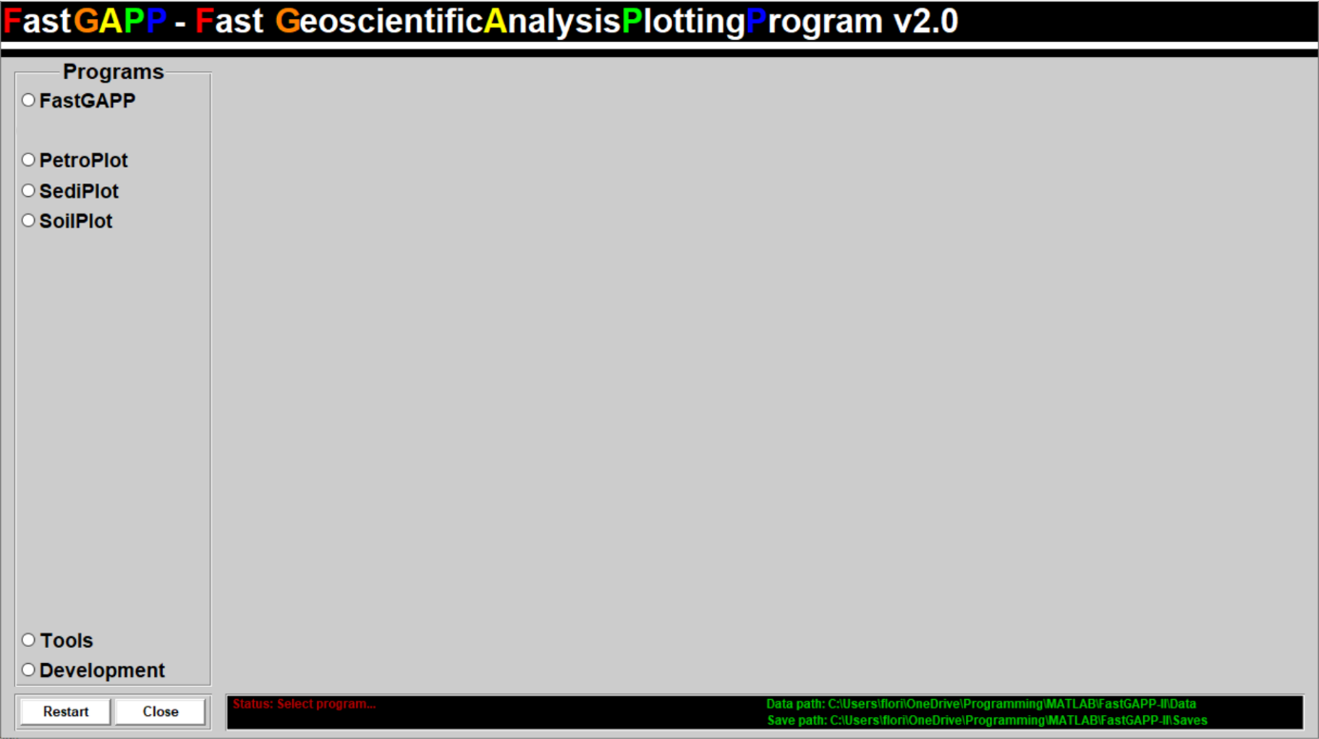

Fig. 2.4‑2: Screenshot of the main window of FastGAPP. The program selection panel allows to select included programs. The dataset selection panel is not visible until any button is selected. The black status bar gives information about the status and currently selected save and data paths.

# First steps with FastGAPP

The following section explains the first steps with FastGAPP. At the beginning, it is explained how to select the sub‑programs (section 3.1). Second, it is explained how to prepare datasets as input for any sub-program (section 3.2). Datasets are generally specific for the sub-program since the sub-programs comprise different header entries. Therefore, supported headers and units are listed for each sub-program after explanation on how to use FastGAPP and explanations on its functionality (section 5-8). In this section, some useful tools are introduced, which will simplify FastGAPP’s usage and save some additional time while working with FastGAPP (section 3.3 and 3.4). Later in this section, the users will learn how to select datasets (section 3.5) and how to load previously saved sessions (section 3.6). At the end of this section, some additional information on how FastGAPP handles and treats data is listed (section 3.7).

## Program selection

Sub-programs of FastGAPP can be selected on the left side of the main window in a panel entitled ‘Programs’ (Fig. 3.1-1). Click on the name of any program. The current selection will be colored in blue and a large panel will appear to the right with several buttons for dataset selections and session loading.

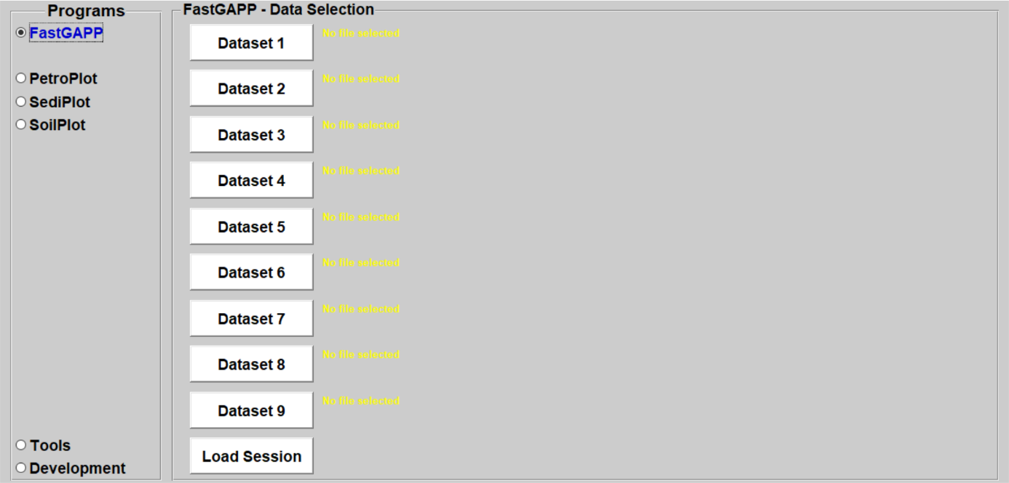

Fig. 3.1‑1: Screenshot after a sub-program (Here, FastGAPP) has been selected in FastGAPP’s main window. After any of FastGAPP’s programs has been selected, a larger panel with several buttons for dataset selection or session loading will appear to the left of the program selection.

## The general structure of an input dataset

The structure of an input dataset is kept as simple as possible. A major improvement to FastGAPP v1.0 is the automatic import of sub-program specific header entries. This still requires a properly prepared dataset but gives many degrees of freedom since sorting is not required anymore. However, there are still some restrictions. An example for an input dataset for PetroPlot v2.0 is shown in Fig. 3.2-1.

Datasets for any program consists of two header rows, whereby the first row (line 1 in Excel spreadsheet) includes the program-specific column headers (in this example Q, A, P…, see Fig. 3.2-1), which specifies the contents of each column. The second row represents the unit corresponding to the column headers (e.g., %, wt.%, or ppm). Following numeric values need to be in this unit! This is in particular important for FastGAPP, where numeric values will be recalculated on the basis of the unit. Logically, the samples and data corresponding to the headers and units in line 1 and 2 start in the third row (line 3). Furthermore, it is required that the sample label is in the first column (in this example P1, P2, P3…, see Fig. 3.2-1).

Among the three major points above, there are several degrees of freedom. Samples must start in row 3 but numeric values do not have start in row 3. The input data can also contain blanks or text. This may be the case if only trace elements were measured with ICP-MS for some, but not all samples. Geochemical data also often contain ‘ND’ or ‘<20ppm’ to indicate that a measured element was below detection limit. Blanks or text elements will be converted to NaN (Not-a-Number) values and are, therefore, ultimately excluded from any calculation (see section 3.7 for more information).

A dataset is allowed to have more columns than the program-specific headers. An example may be the presence of longitude / latitude, depth or other comments / remarks (e.g., geological formation, texture, macroscopic descriptions) anywhere in the spreadsheet. There is no need to delete them out of any dataset. All sub-programs only import the program-specific headers, which are listed for each sub-program in section 5-8.

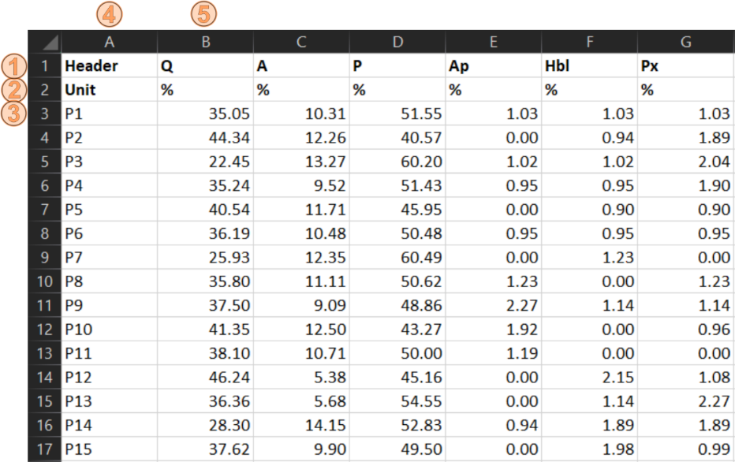Fig. 3.2‑1: Example dataset to explain the general structure of datasets for any program included in FastGAPP. This example represents a dataset for PetroPlot v2.0. Line 1 (1) and 2 (2) are required to include the headers (Q, A, P, Ap, Hbl, and Px) and corresponding units (%). The samples start in row 3 of column A (3). Column A (4) is required to represent the sample label / number. The headers and data start in column B (5) in this example.

The most important things to consider during the preparation of a dataset shortly repeated:

* First column: Sample name / number starting in row 3.
* First row: Program-specific column headers. Other header (e.g., comments can be also present, but will not be imported into the programs)
* Second row: Valid units corresponding to the column headers. Surely, following numeric values need to be in this unit.

Finally, several example files are included in the FastGAPP program folder ‘example_datasets’, which can help for orientation during the preparation of a dataset.

## Tools - Changing save and data paths

File selection windows like those shown for dataset selection or session loading will start in the current selected folder. This can lead to unnecessary and annoying clicking and searching for the directory where the input data is stored or where the data (saved session and figures) should be saved. To avoid this, there are two buttons in FastGAPP in the ‘Tools’ panel, which allow to change the standard data and save paths. Click on ‘Tools’ in the program selection panel (Fig. 3.2-1). By clicking ‘Data path’ and ‘Save path’ (Fig. 3.3-1), a new window for folder selection opens (Fig. 3.3‑2). Navigate by clicking and select the preferred directory. Confirm with a click on folder selection. The workflow for ‘Data path’ and ‘Save path’ is the same. After folder selection, a new file fgapp20.config is created in the FastGAPP directory. The fgapp20.config file is automatically loaded when FastGAPP starts. Presence of the configuration file is indicated in the command window during initialization of FastGAPP (Fig. 2.4-1). Using the same tool multiple times will overwrite the previously selected directories. To completely reset the data and save paths, use the ‘Clear config file’ button also found in the tools panel (Fig. 3.3‑1). The currently selected folders are also shown and updated in the status panel (Fig. 3.3-3).

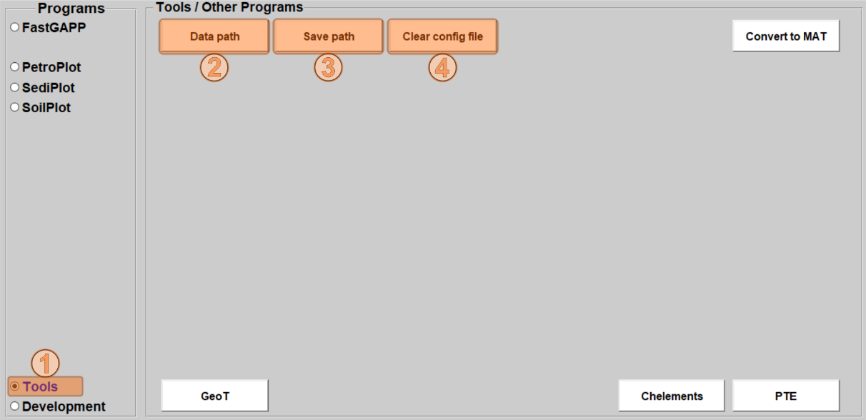

Fig. 3.3‑1: The tools to setup the data and save paths are located in the ‘Tools’ section. Click on ‘Tools’ in the program selection (1) and then press the ‘Data path’ (2) and/or ‘Save path’ (3) button to select each path. Usage of these buttons with a valid selection will create or modify the fgapp20.config file where these paths are stored. The config file can be deleted by using the ‘Clear config file’ button (4).

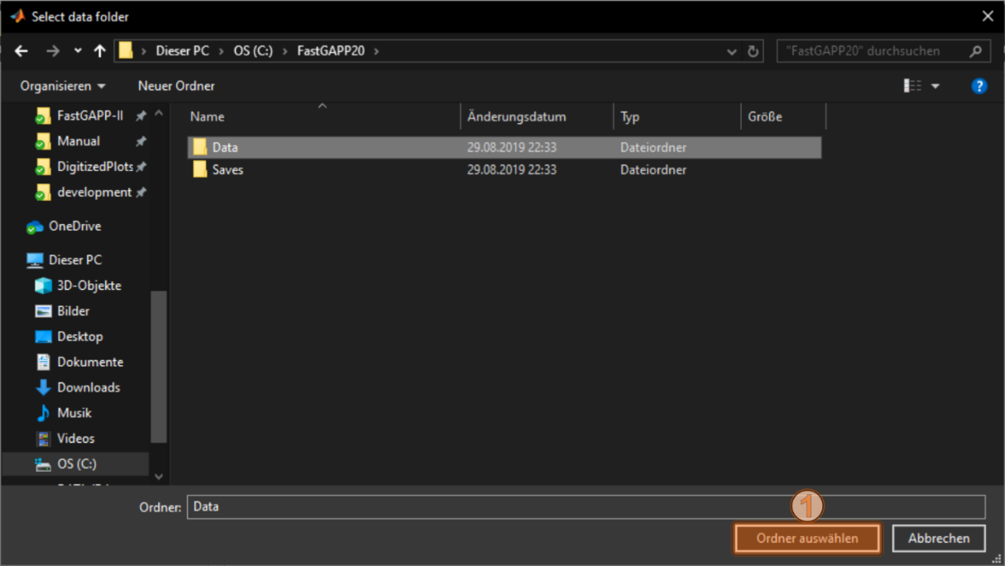

Fig. 3.3‑2: Screenshot of the folder selection window. Navigate through your system to find the preferred location and mark the folder. Confirm by a click on the ‘Select folder’ button (1).



Fig. 3.3‑3: The status panel shows the currently selected data and save paths. The default directory of the selection windows for loading and saving files is the FastGAPP directory. After the selection of new directories (see Figs. 3.3-1 & 3.3‑2), the data and save paths are updated.

## Tools - Converting spreadsheets (.xls/.xlsx) into MATLAB (.mat) files

After the Excel spreadsheet has been properly prepared and the correct format as explained in section 3.2, it can be read and imported by the sub-programs of FastGAPP. Generally, importing an Excel spreadsheet to MATLAB requires some processor time. Importing mat-files – the native MATLAB format – is much faster, especially for large datasets and high numbers of datasets. Although not necessary, converting Excel spreadsheets into mat-files before using any of the sub-programs is much more efficient. The small tool ‘Convert to MAT’ is integrated in FastGAPP to automatically perform this conversion.

### How to start and use of the ‘Convert 2 MAT’ tool

To access the tool ‘Convert to MAT’, click on ‘Tools’ in the program selection (Fig. 3.4-1) and then click on the ‘Convert to MAT’ button. Afterwards, a new window for file selection opens (Fig. 3.4-2).

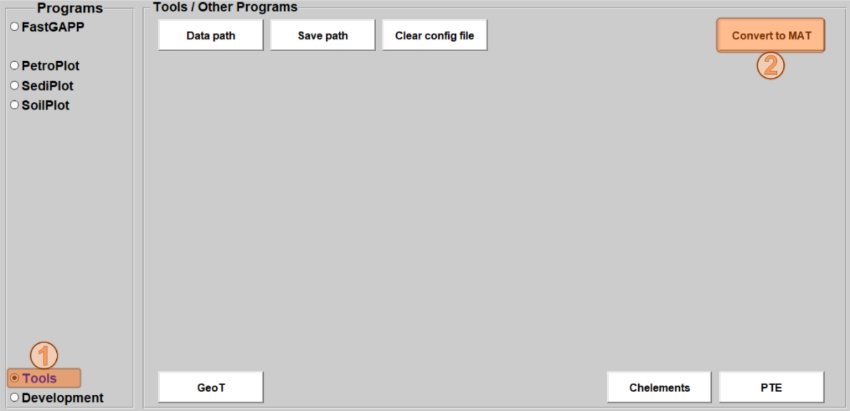

Fig. 3.4‑1: The tool ‘Convert to MAT’ is also located in the ‘Tools’ section. Click on ‘Tools’ in the program selection (1) and then press the ‘Convert to MAT’ button to start the conversion tool.

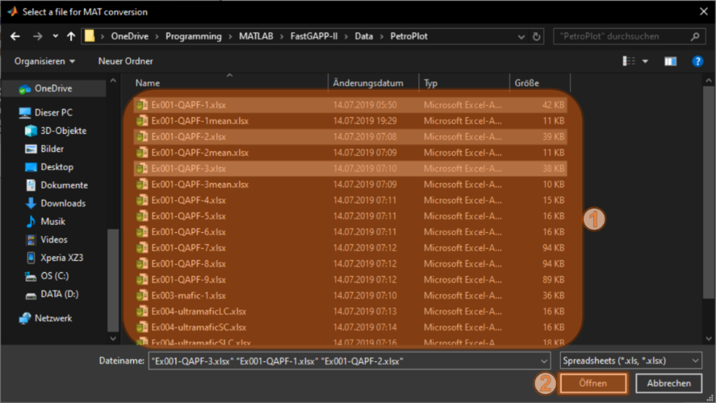Fig. 3.4‑2: Screenshot of the file selection window of the tool ‘Convert to MAT’. Navigate to the directory, which contains Excel spreadsheets to convert, Select the spreadsheet/s from the file list (1). Multi-selection is enabled in this file selection window. In this example, the three Excel spreadsheets Ex001-QAPF.xlsx, Ex002-QAPF.xlsx, and Ex003-QAPF.xlsx have been selected. By clicking on ‘Open’, the conversion will start and write some status reports on the MATLAB command window (Fig. 3.4-2).

Navigate to the folder where the Excel spreadsheets are stored and selected one or more Excel spreadsheets. In contrast to other file selection windows in FastGAPP, the ‘Convert to MAT’ tool supports multi-selection by dragging the mouse or using Shift / Ctrl in combination with the mouse. After file selection (Fig. 3.4‑2), press on the ‘Open’ button of the file selection window. The selected Excel spreadsheets will be now converted into mat-files in background. This may take some seconds. The new mat-files will have the same file name as the spreadsheet and are created in the same directory. Note: If mat-file with the same name are already existing in the directory, these will be overwritten without any prompt or any further notice! The tool ‘Convert to MAT’ will write status information on the MATLAB command window during processing the data (Fig 3.4-3).

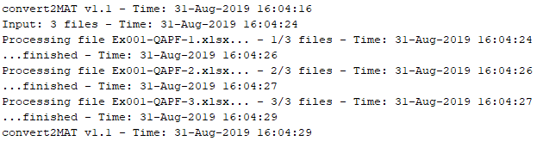Fig. 3.4‑3: Screenshot of the MATLAB command window after using the tool ‘Convert to MAT’. The three previously selected Excel spreadsheets Ex001-QAPF.xlsx, Ex002-QAPF.xlsx, and Ex003-QAPF.xlsx have been successfully converted into MAT files. The created MAT files will be in the same directory as the Excel spreadsheets.

### Developer notes - Additional information on the mat-file format for FastGAPP

Excel spreadsheets can be imported by the MATLAB command ‘xlsread’. Datasets for FastGAPP contain heterogenous data types (numeric and text). Therefore, the created variables by ‘xlsread’ comprise (I) a ‘num’ variable – a double array, which contains only numeric entries, (II) a ‘txt’ variable – a cell array, which contains only text entries, (III) a ‘raw’ variable - a cell array, which contains both, numeric and text entries. In the previous version of FastGAPP, the data was read out of the ‘num’ and ‘txt’ variables. In contrast, in FastGAPP v2.0, all data is read out from the ‘raw’ variable, which is less efficient, but simplified the code. However, all three variables are still created in FastGAPP v2.0 when ‘xlsread’ is used. Therefore, the converted mat-files also contain these three variables ‘num’, ‘txt’, and ‘raw’ to use the same workflow after Excel spreadsheets and datasets as mat-files are imported.

## Dataset selection

After any sub-program has been selected in the program selection panel, datasets can be selected by using the buttons of the dataset selection panel (Fig. 3.5-1). It is possible to select up to nine datasets for a session. To select any prepared dataset, click on any of the dataset button like the ‘Dataset #1’ button (Fig. 3.5 ‑1). This will open a new file selection window (Fig. 3.5-1). Here, navigate to the folder where the dataset is stored, click on it select it and confirm with a click on the ‘Open’ button. Use the popup to change the shown file types (mat-files vs. Excel spreadsheets) in the file selection window (Fig. 3.5-2).

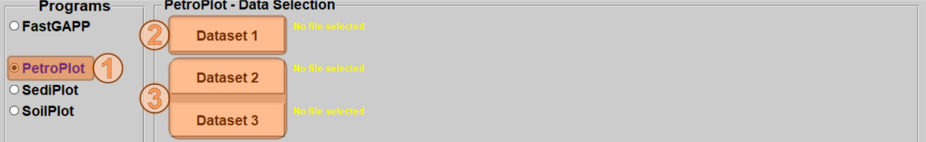

Fig. 3.5‑1: Screenshot of the program selection and dataset selection panels. Select a program (1) and use the ‘Dataset #1’ button (2) to select the first input dataset. This will open a file selection window (Fig. 3.5-2) where datasets can be loaded. If more datasets are intended to be imported, use the other available buttons (3).

After the file selection has been confirmed by clicking the ‘Open’ button in the file selection window, the window will disappear and FastGAPP checks if the selected file’s extension was correct (‘.mat’, ’.xlsx’, or ’.xls’). If the file extension is not valid, the button will change to red color. If so, select another file with valid file extension. If the selected file is valid, the button will change to green color and some green text showing the absolute file’s path and name and a statement that the selected file extension was correct. After any file with valid file extension has been selected by using one of the nine buttons, the green ‘Start’ button will appear in the dataset selection panel of FastGAPP’s main window. Clicking the ‘Start’ button will finally import the selected dataset from the input file and start the program (see section 3.7).

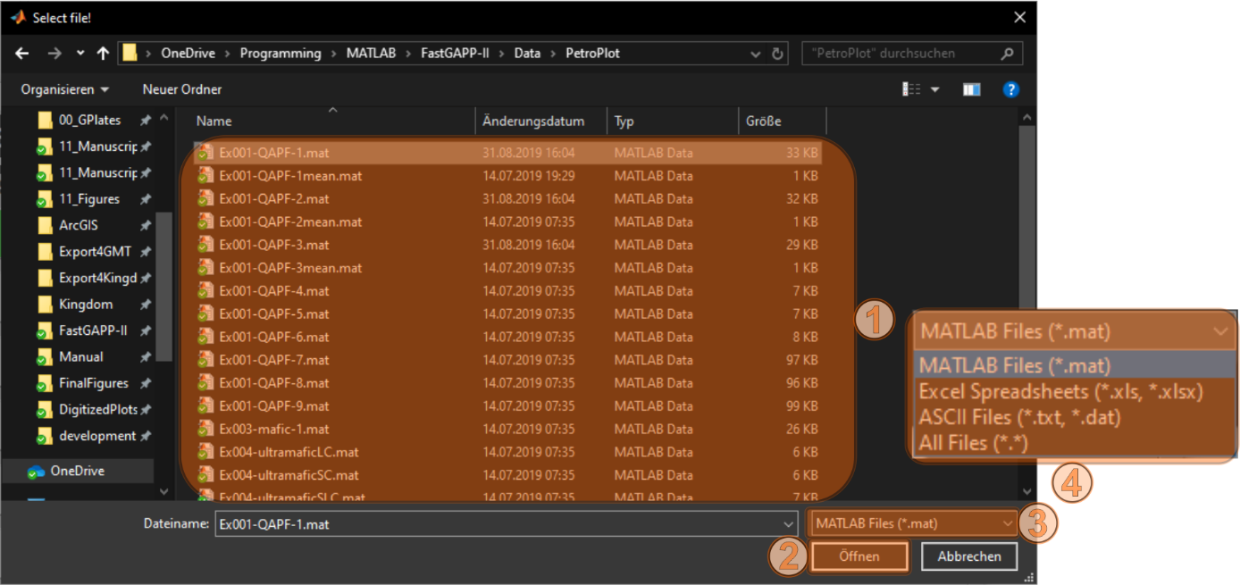

Fig. 3.5‑2: Screenshot of the dataset selection window. After the data selection window has been opened, navigate to the folder where the dataset is located and select the preferred dataset (here: Ex001-QAPF-1.mat) by clicking on it. After that, click on the ‘Open’ button to confirm the selection.

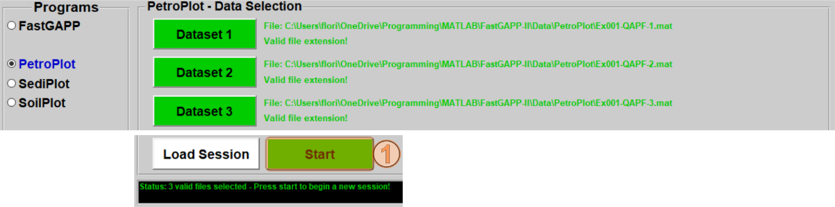

Fig. 3.5‑3: Screenshot of the program selection and dataset selection panels after three files have been selected. The green ‘Start’ button appears and the program (PetroPlot in this example) can be started by clicking on it (1).

### Further information

Note, that the order of the selected datasets will also control the plotting order of the datasets, which cannot be changed in a session. This means that dataset #1 will always be on top of all other datasets (= the last dataset to be plotted). Dataset #9 will always be on the lowermost level (= the first dataset to be plotted). The user should think about the order of the datasets before their selection and start-up of a session! Among that, datasets do not need to be selected in continuative order. It is also possible to select input files for dataset #3, dataset #4, and dataset #8, but this will be automatically and consecutively ordered after pressing the ‘Start’ button (see section 3.7).

## Loading a session

Sessions of any sub-program can be saved by clicking on the ‘Save Session’ button in the main window of the sub-programs (see section 4.9). Although how save sessions has not been explained yet, it is explained in this section. Session files contains all imported dataset/s and all adjustments of the marker / labels / plots made during session (see sections 4.3, 4.5, 4.6).

First, select program by using the radio buttons in the program selection panel (see section 3.1). After the dataset button and the ‘Load Session’ appeared, click on the ‘Load Session’ button to the window for the session selection (Fig. 3.6-1). Second, navigate through the directories to navigate to the session file intended to open (Fig. 3.6-2), click on it and click on the ‘Open’ button to confirm. After that, the dataset buttons turn into green color and shows the absolutes path and file names contained in this session file (Fig. 3.6-3). The ‘Load Session’ and ‘Start’ buttons also change to green colors to confirm that the session is loaded and ready to start. Finally, press the ‘Start’ button to open the selected session. Learn more what happens after the start buttons is pressed in section (section 3.7).

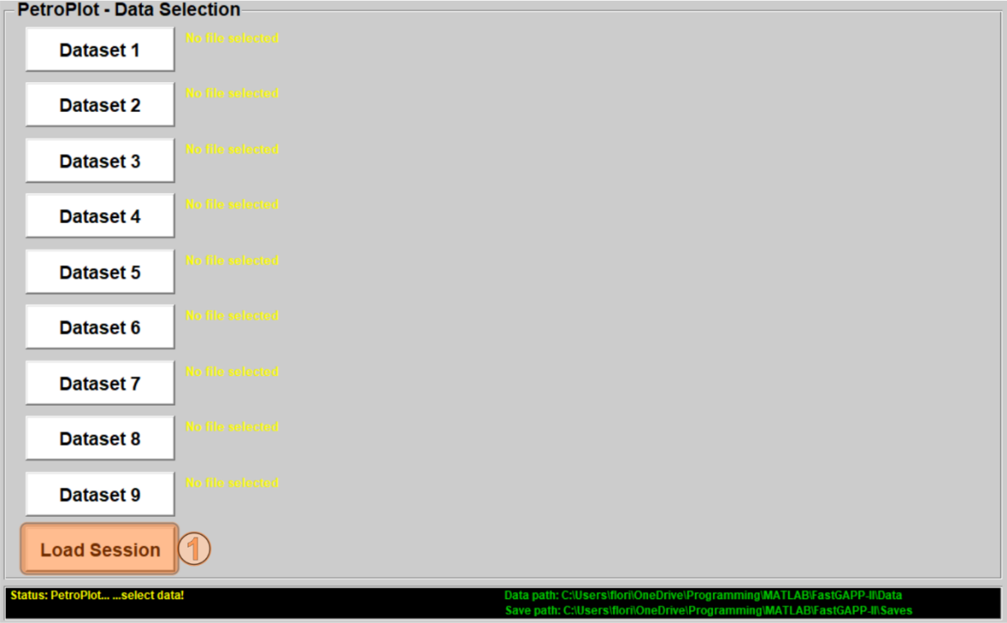

Fig. 3.6‑1: Screenshot of the data selection panel. To load a session, click on the ‘Load Session’ button (1). Afterwards a new session selection window will open (Fig. 3.6-2).

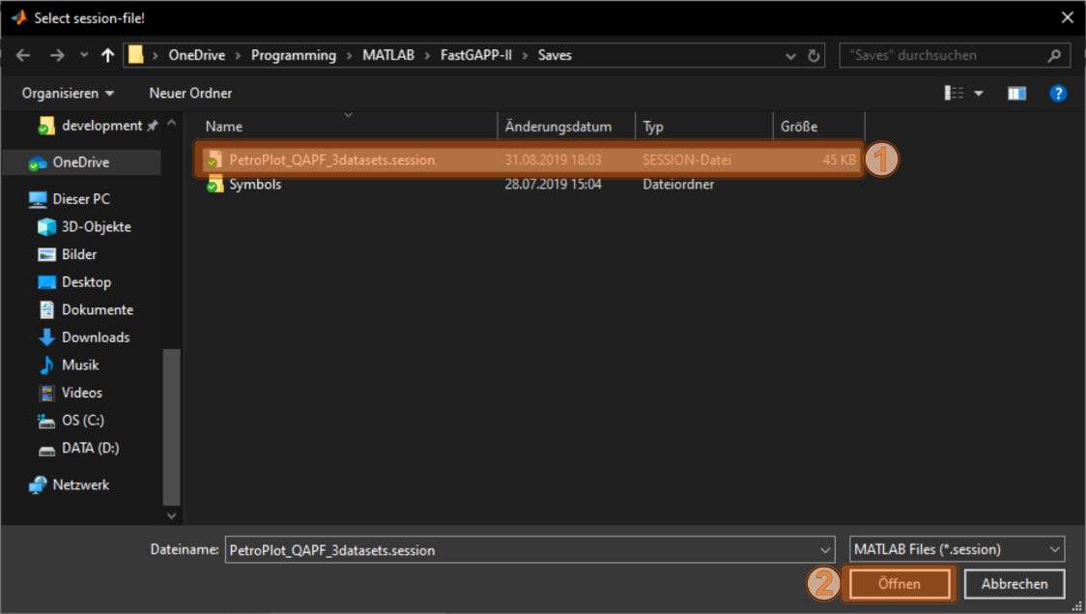

Fig. 3.6‑2: Screenshot of the session selection window. To load a session, navigate to the folder where the session is stored and select a session file from the file list (1). Finally, press the ‘Open’ button to select this session.

Note that session files are logically restricted to the sub-program in which the session was saved (i.e., sessions saved in PetroPlot can only be opened with PetroPlot). If a session from another program is tried to be loaded, a message will appear and inform the user that the dataset was created with another sub-program.

After a session has been loaded, more datasets can be still selected by the dataset buttons in the data selection panel. If this is done, the session will not be longer loaded. Moreover, it will be checked if the contained files from the session still exist in the original paths when the session was saved. If so, the datasets will be imported again together with the newly selected dataset/datasets into a new session. This will be indicated by the changing color of the ‘Load Session’ button and notifications if the files do not exist in the given path anymore.

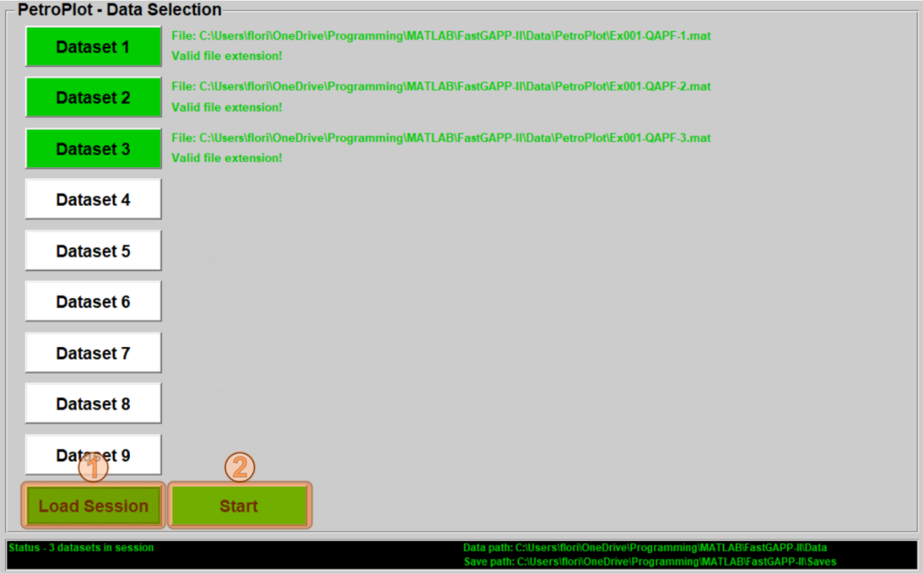

Fig. 3.6‑3: Screenshot of the dataset selection panel after the session has been selected (Fig. 3.6-2). ‘Load Session’ button (1) and ‘Start’ button (2) changed their color to green. The session can be now loaded by clicking the ‘Start’ button (2). Note that the paths and filenames, which are shown next to the dataset buttons refer to the path and filename at the time this session was saved. If another dataset is selected by using any of dataset buttons, FastGAPP will check for the presence of all files, which were listed in the session. However, then the datasets will be newly imported and not be loaded from the session anymore. This will be indicated by the changing color of the ‘Load Session’ button.

## Starting the session and data processing

After a dataset or more datasets has/have been selected, the sub-program can be started by clicking on the green ‘Start’ button in the data selection panel (see Fig. 3.5-3). Well done, the sub-program starts now, and its main window opens. This may take some seconds. This would be a short section, but in the following section some additional (but basic) information on the data processing is listed.

### Further information – Default marker / labels and file import

After any sub-program has been started, the program-specific information, which includes valid program-specific headers and the list of plots, will be loaded into the control structure (Fig. 3.7-1). The list of files will be also checked for consistency and continuously arranged (see further information in section 3.5). The file list will be also stored in the control structure. After the file list has been continuously arranged, the data structure is created. First, the default setups for symbols and labels will be loaded and stored in the data structure for every imported dataset. Afterwards, the files will be imported with the MATLAB commands corresponding to input file type (Fig. 3.7-1). A loop iteratively searches through the first line of each imported dataset for program-specific header entries and - if found – the loop writes the corresponding units and numeric values below these header entries into the data structure. Statistics of the numeric data like minimum, median, mean and maximum are also already calculated and stored in the data structure. The progress of import and recalculations will be indicated a progress bar.

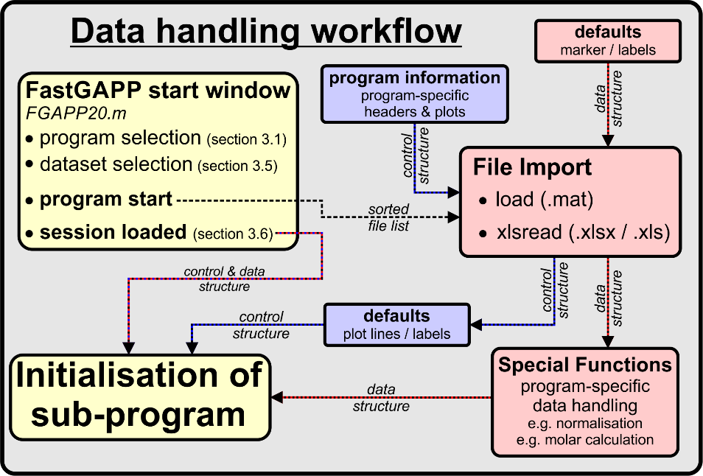

Fig. 3.7‑1: Flow diagram of data handling and processing after starting any sub-program of FastGAPP. The flow diagram indicates the path of the control structure (blueish colors) and data structure (reddish colors) through the different steps. See text for further explanation.

### Further information - NaN values

If any header entry was not present in the input file, the variables for these headers will be still written into the data structure. The arrays will have the same size as the arrays for present header entries. Instead of any data, NaN’s will be in these arrays stored the data structure. Accordingly, these data will not have any influence on any recalculation or will not be present in the plots. This way decided by the developer, slightly decreases the performance of the code since more memory will be used but allow simpler handling of the data.

Among non-present header entries, NaN’s will be also written when blanks or text were present were numeric entries are expected. As explained in section 3.2, this may be the case in heterogenous datasets if main and / or trace elements have not been completely measured throughout the samples. Another case would be that the measured elements were below the detection limit of the instruments (e.g., ‘<5’, ‘<5ppm’, ‘ND’, or ‘DT’). In these cases, these specific entries will be turned into NaN’s and not be present in the numeric values. NaN arrays for header entries will be also created if any header entry was present in the dataset, but no numeric values were found below. This will be explicitly indicated in the data overview panel after the sub-program has been started (see section 4.2).

### Further information - Data processing and defaults plot lines and labels

After importing and storing the input data into the data structure, this structure is passed into the special function (Fig. 3.7-1). The special function handles input data in a program-specific way dependent on the sub-program. In FastGAPP for example, new values will be calculated (e.g., conversion of Fe2O3 to FeO, normalization to 100 wt.% and molar conversion, see section 5.2) and some values may be recalculated if the units given in the input file do not match those for the internal storage (see sections 5.1 and 5.2). All newly created data will be also stored in the data structure. Special functions are program-specific, and therefore, further details are listed in sections 5-8.

Default plot lines / labels are loaded into the control structure after the special function performed the data processing (Fig. 3.7-1). The functions for the default lines / labels contain all necessary information required for plotting.

### Further information - Initialization of the main window and loaded sessions

After all these steps explained above the main window is initialized. The main window processes all information like the valid header entries in the input data, list of plots, defaults symbol / line / label information and processed datasets (Fig. 3.7-1). After that, it is possible to create plots from the input datasets.

If a session has been loaded, the flow is completely different since session already contain the processed data. Additionally, sessions contain information about changes of the plot, line and symbol appearance done in the session. Sessions will be directly loaded by the main window (Fig. 3.7‑1).

# General functionality of the main windows

The following section explains the basic functionality of the main windows of FastGAPP and other sub-programs. Basically, two different types of main windows exist for the different programs, which are only slightly different (Fig. 4.0-1). The first one is used for PetroPlot, SediPlot, and SoilPlot (internally listed as type 2 main window). The second main window (internally listed as type 1 main window) is a further development of the first main window. The functionality of the type 1 main window is slightly increased to handle the larger number of plots and valid headers of FastGAPP (Fig. 4.0-1).

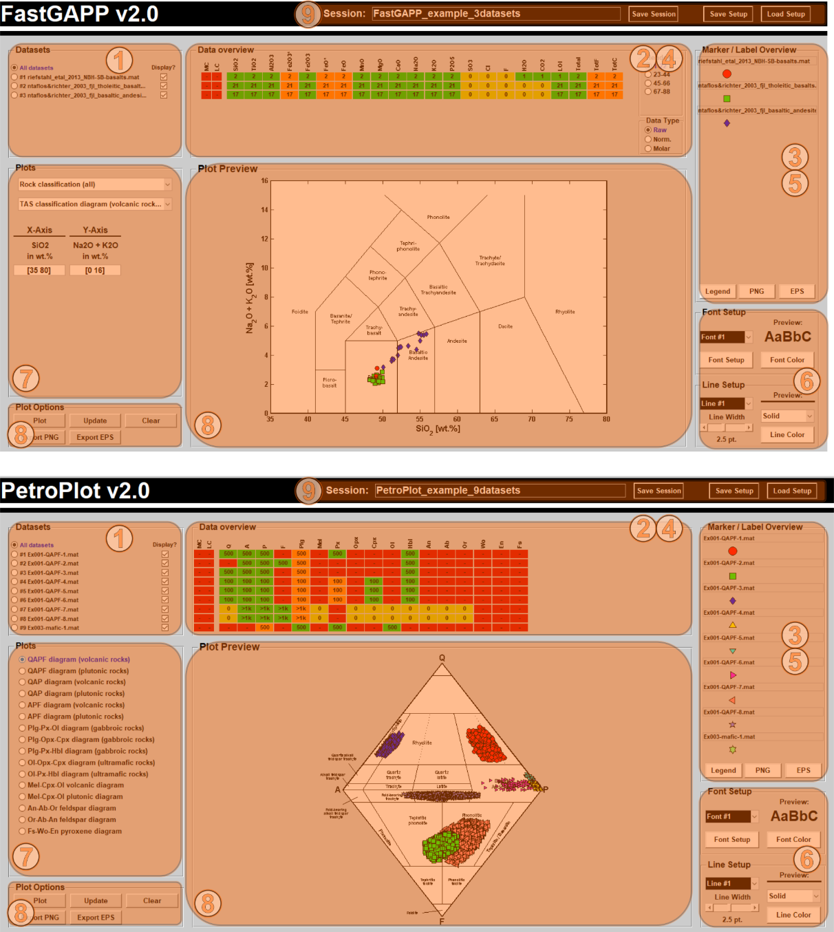

Fig. 4.0‑1: Screenshots of the main windows of PetroPlot v2.0 (bottom, type 2 main window) and FastGAPP v2.0 (top, type 1 main window). Both main windows consist of (1) the dataset selection panel (section 4.1), (2) the data overview panel (section 4.2), (3) marker and label overview panel (section 4.3), (6) the font and line setup panels (section 4.6), (7) the plot selection panel (section 4.7), the plot options and plot preview (section 4.8), and (9) buttons to save / load symbols and to save the session (section 4.9). If any dataset instead of ‘All datasets’ is selected in the dataset selection panel (1), the data overview (2) and marker / label overview panels (3) will be replaced by the (4) dataset overview panel (section 4.4) and (5) the marker / label setup panels (section 4.5) for the currently selected dataset.

The workflow and start up, however, is the same for both types of main window. The type 2 main window for PetroPlot, SediPlot and SoilPlot has only limited space for headers and plots in the data overview and plot selection panels (Fig. 4.0-1). The higher number of different plots, handling raw, normalized, and molar geochemical data and the higher number of headers for FastGAPP required slightly further development and restructure of the data overview and plot selection panel. The result of this progressive development is the type 1 main window for FastGAPP (Fig. 4.0-1). All differences and the different functionalities are explained in this section.

## Dataset selection panel

The dataset selection panel is a main component of the main windows. With this panel it is possible to control the appearance main window, i.e. to change to dataset table view and to marker / label setup panel and back to data overview and marker / label overview panel. After starting any sub-program, the radio button ‘All datasets’ is selected (Fig. 4.1-1). This means that all datasets are shown in the plot preview or in the final plot, if numeric data for that plot is available. Single or multiple datasets can be deactivated or again activated for plotting, by un-checking or checking the checkboxes to the right side of the dataset selection panel (Fig. 4.1-1).

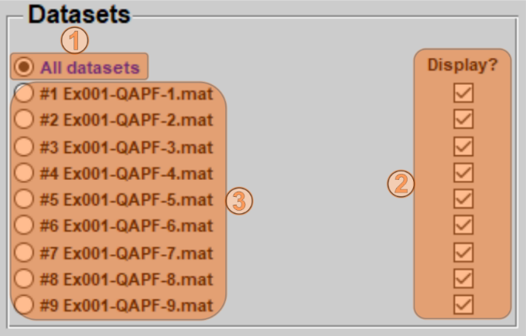Fig. 4.1‑1: Screenshot of the dataset selection panel. Functionality is the same in all programs. After the startup of any program ‘All datasets’ (1) is always selected. With this setup all imported datasets will be plotted if (I) the data for the selected plot is available and not NaN (see section 3.7) or (II) if the datasets are checked for displaying on the right side of the panel (2). If any dataset is unchecked for displaying by clicking on any of the checkboxes (2) it will be not shown in the plot preview and final plot. If any of the radio buttons among ‘All datasets’ is selected by clicking (3), only this dataset will be shown in the plot and the main window will change is appearance by showing the dataset table view and marker / label setup panel for the corresponding dataset.

Selection of any dataset by clicking one of the radio buttons below ‘All datasets’ (Fig. 4.1-1), will switch to the dataset table view and the marker / label setup for the currently selected dataset (see sections 4.4 to 4.5). Moreover, only the currently selected dataset will be then shown in the plot preview and final plots.

## Data overview panel

The intention for the data overview panels is to give a detailed overview about the data imported into any sub-program (Fig. 4.2-1). In this circuit-diagram-like presentation, rows correspond to the imported datasets as they are listed in the dataset selection panel left of the data overview panel (Figs. 4.0-1 and 4.1-1). Columns correspond to the program-specific header values. The numbers on the rectangles indicate the number of numeric values found for this header in each input dataset. Numbers on the rectangles are only displayed up to 999, higher amounts of numeric values are abbreviated as e.g. >1k. The color of the rectangles represents the status of the input data. Different colors indicate, e.g. if the data corresponding header values have been found (or not) or if they were calculated:

* **green** = this header value has been found with numeric values.
* **orange** = this header values was not present, but the values have been calculated from other numeric values (this is program-specific, see sections 5.2, 6.2, 7.2 for more information).
* **yellow** = this header value was present in the input file, but no numeric values were present.
* **red** = the header value was not present in the input file.

During the data import, some statistics like mean, median, minimum or maximum are created. Moving the mouse over any of the rectangles will open a tool tip, which shows these statistics.

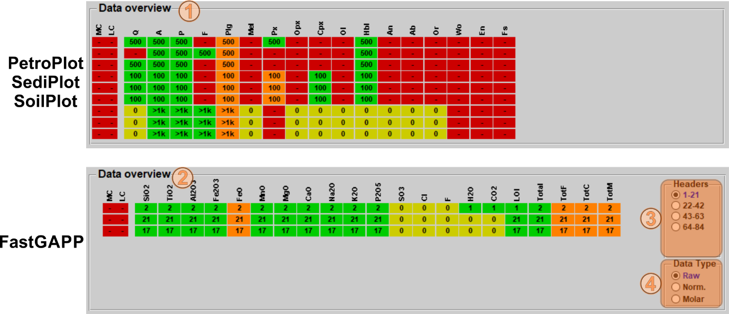

Fig. 4.2‑1: Screenshots of the data overview panel of PetroPlot v2.0 (1; type 2 main window) with nine imported datasets and FastGAPP v2.0 with three imported datasets (2; type 1 main window). Tool tips with some more information about each header entry can be shown by moving the mouse over any of the rectangles. In FastGAPP (type 1 main window) two sub-panels ‘Headers’ (3) and ‘Data Type’ (4) are located on the right side of the data overview panel. Clicking any of the contained radio buttons will switch the shown header entries (3) or the shown data types (4).

In FastGAPP (type 1 main window), there are two sub-panels on the right side of the data overview panel (Fig. 4.2-1). By clicking on any of the radio buttons in the upper sub-panel ‘Headers’ (Fig. 4.2-1), the shown header values are shifted to different headers entries. This was necessary because if the large number of header values for FastGAPP. Since FastGAPP also normalizes raw data to 100 wt.% and recalculates the raw data to molar data, clicking on the radio buttons in the lower panel ‘Data Type’ (Fig. 4.2-1) will switch the view to another data type. If any dataset is selected instead of ‘All datasets’ in the dataset selection panel (see section 4.1), the data overview panel will disappear, and the dataset overview table will be shown at the same position of the main window.

## Marker / Label overview panel

The marker / label overview panel is located on the right side of all main window types (Fig. 4.0-1). It is a legend-like illustration of the currently selected symbols and labels for each dataset (Fig. 4.1-1). If only three datasets are imported, then logically only three entries will be shown in this panel. Labels will only be visible in the marker /label overview panel if these are activated in the marker / label setup panel for any dataset (see section 4.5). If marker and / or label columns are present in the input data this will be also indicated in the marker / label overview panel (see section 9 for further information).

After startup of any sub-program, the input file name will be shown in the editable fields of the marker / label overview panel (Fig. 4.3-1). By editing these the name of the can be changed. This name is only shown the marker / label overview panel, opened legends or exported legends. The original input file names, however, will be still shown in the dataset selection panel (Fig. 4.1-1).

Three buttons are located at the bottom of the marker /label overview panel (Fig. 4.3-1). By clicking these buttons, it is possible to open the legend in a separate window and / or export the legend as encapsulated postscript (.eps) or portable network graphics (.png). Export as .eps or .png opens a new window to save a file.

To change the symbols and / or to show labels for each sample, any dataset needs to be selected in the dataset selection panel (see section 4.1, Fig. 4.1-1). The marker / label overview will then disappear and the marker / label setup panel (see section 4.5) will appear at this position in the main window.

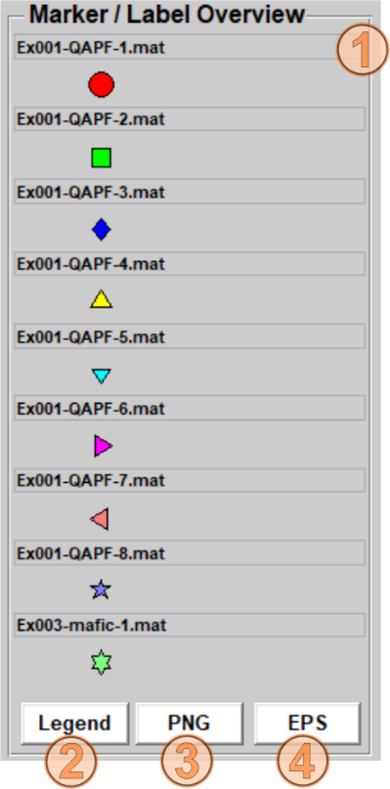Fig. 4.3‑1: Screenshot of the marker / label overview panel. In this example nine datasets have been imported to PetroPlot v2.0. The text in the editable field is the name of the input file (1). This text will also appear in the separate figure legend (2), legend as .png raster image (3), or legend as .eps vector graphics (4) when one of these buttons is pressed. The marker below is the current selected marker for the dataset. If sample labels for any dataset are activated, these will be also shown right of the marker. If marker or label columns are present in any dataset (see section 9), text will be shown stating that instead of a single symbol.

## Dataset overview table

After starting any sub-program, the dataset overview table will not be visible (Fig. 4.0-1). It appears after any dataset instead of ‘All datasets’ has been selected by clicking on the radio buttons in the dataset selection panel (see section 4.1, Fig. 4.1-1). The data overview panel disappears, and the dataset overview table will be shown (Fig. 4.4-1) at this position of the main window.

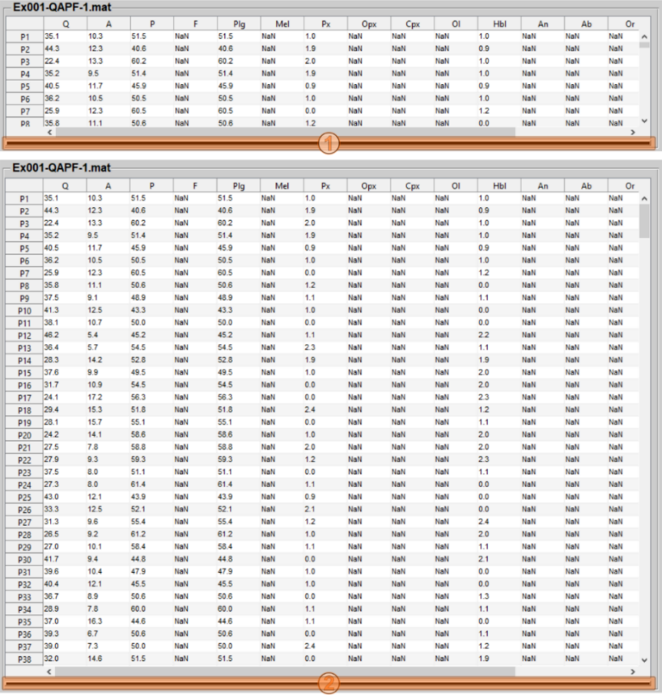Fig. 4.4‑1: Screenshots of the collapsed dataset overview table (top) and the expanded dataset overview table (bottom). The dataset overview table can be expanded and collapsed by the black bar directly below the table (1 & 2).

In this table, the data of the currently selected dataset and currently selected data type will be shown (Fig. 4.4-1). The row headers represent the sample labels or numbers, which were in the first column of the input dataset. The column headers represent the program-specific header values. If the header was missing in the input file, the header will be still shown in this table, but overall with NaN values (section 3.7). If data was missing in the input data (no data, or text like ‘<5ppm’), these values were also replaced by NaN’s. It is possible to scroll horizontally and vertically through the imported dataset. To show another input dataset, the current selection in the data selection panel must be changed for another dataset (Fig.  4.4-1).

To change the view to another data type (i.e. raw, normalized or molar data), the data type has to be switched in data overview panel (see section 4.2). Click on the ‘All datasets’ radio button to switch, then use the data type selection panel (Fig. 4.2-1) in the dataset selection panel to select another data type. Select another radio button in the data selection panel to switch again to the data overview table. The data corresponding to the selected data type will be now present.

## Marker / Label setup panel

Similar to the data overview panel, the marker / label setup panel (Fig. 4.5-1) is only be visible if any dataset instead of ‘All datasets’ is selected in the dataset selection panel (see section 4.1). By clicking on any of the dataset in the dataset selection panel, the marker / label setup panel appears at the position where the marker / label overview panel was. By using the marker / label setup panel it is possible to control the marker and label appearance for the currently selected dataset. The upper part of the panel consists of a preview of the marker and label appearance (Fig. 4.5-1). Below the preview, several elements allow to control the markers appearance. The popup below the preview allows the change the marker type (e.g., circle, square, triangle…). The two sliders allow to change the marker size and the marker edge width. Furthermore, clicking one of the two buttons allow to change the marker face color and the marker edge color.

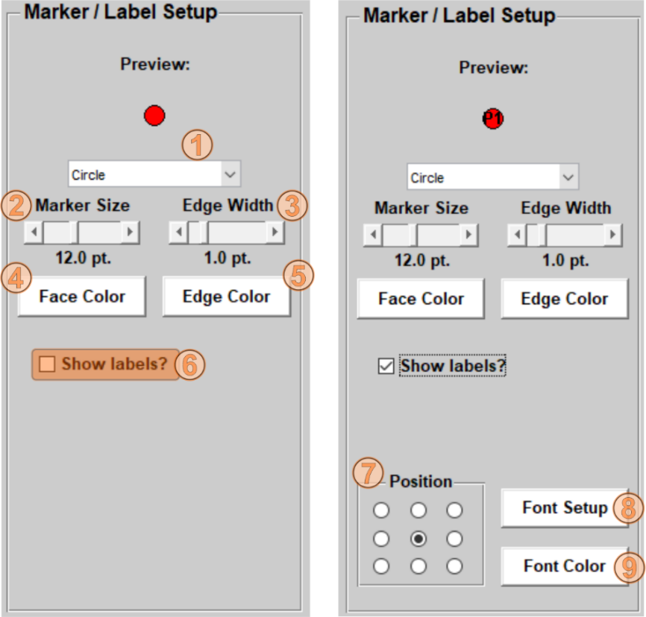Fig. 4.5‑1: Screenshots of the marker / label setup panel with deactivated (left) and activated labels (right). The marker style (circle, square, triangle…) can be changed by using the popup (1). Using the sliders will change the marker size (2) and the marker’s edge width (3). Colors of the marker face and edge can be adjusted with the menus, which open by clicking on the ‘Face Color’ (4) and ‘Edge Color’ (5) buttons. Sample labels for the dataset can be activated by checking the ‘Show labels?’ checkbox (6). After activation of the labels the label position can be adjusted by clicking the radio buttons (7) and font style and color can be changed by the menus, which open after clicking the ‘Font Setup’ and ‘Font Color’ buttons.

Sample labels are by default deactivated for plotting and can be activated by clicking on the checkbox entitled ‘Show labels?’ (Fig. 4.5-1). After clicking on the checkbox, a single label will be shown in the preview at the top of the marker (Fig. 4.5-1) and more control elements for the label appear. The small panel ‘Position’ with the included radio buttons allows to adjust the position of the label relative to the marker by clicking on any of the radio buttons. Furthermore, two buttons are right of the label positioning panel (Fig. 4.5-1). These buttons open new menus for font setup (font type, font style and font size) and font color selection.

Select another dataset in the dataset selection panel to change and adjust markers and labels for these datasets. If marker or label columns were present in the imported datasets, then these will be automatically enabled (see section 9). Two more checkboxes will appear and allow to override the marker and / or label columns.

## Font & Line setup panels

By using the font and line setup panels (Fig. 4.6-1) it is possible to change the appearance of the plots. Both consist of a popup to select a specific font or line number and a preview, which will update when another line / font has been selected or style has been adjusted. Adjustable options for the fonts include font type, font size, and font style (bold, italic…). The font setup and color menus can be opened by clicking the corresponding button (Fig. 4.6-1). Lines can be adjusted by using the line style popup, the line width slider and the line color button (Fig. 4.6-1), which opens a new menu for color selection. Note that not all font and / or line numbers will be present in the selected plot (see further information).

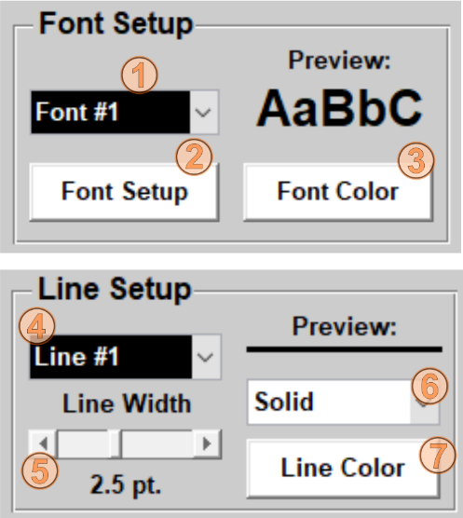Fig. 4.6‑1: Screenshot of the font setup (left) and line setup (right) panels. By using the popups, the current font (1) or line (4) number can be selected. Fonts can be adjusted in the menus opened after clicking on the ‘Font Setup’ (2) or ‘Font Color’ (3) buttons. Line appearance can be changed by using the line width slider (5), the line style popup (6) or the menu opened by a click on the ‘Line Color’ button.

### Further information

As mentioned above not all font and line numbers are present in any selected plot. However, (I) in all plots font #1 and line #1 are the axis title and frame lines, (II) in most cases plots lines and labels are font #2 and line #2. Only if any plot in the original publications had more than one single line type or if some labels were too large to fit in a field, then fonts and lines with higher number were used in the plots.

The developer is not completely happy with this issue and still searching for an easier and better solution! Nevertheless, it works well! 😉 However, the developer hopes to simplify this in a future version!

## Plot selection panel

Different types of the plot selection panels exist in the two different main window types.

In the type 2 main windows (PetroPlot, SediPlot, and SoilPlot), there is only small number of plots available. Several radio buttons are present to select the plot (Fig. 4.7-1). Click on any of these radio buttons to select any plot. There is an auto-update function in the type 2 main window, which refreshes the plot preview after a new plot has been selected.

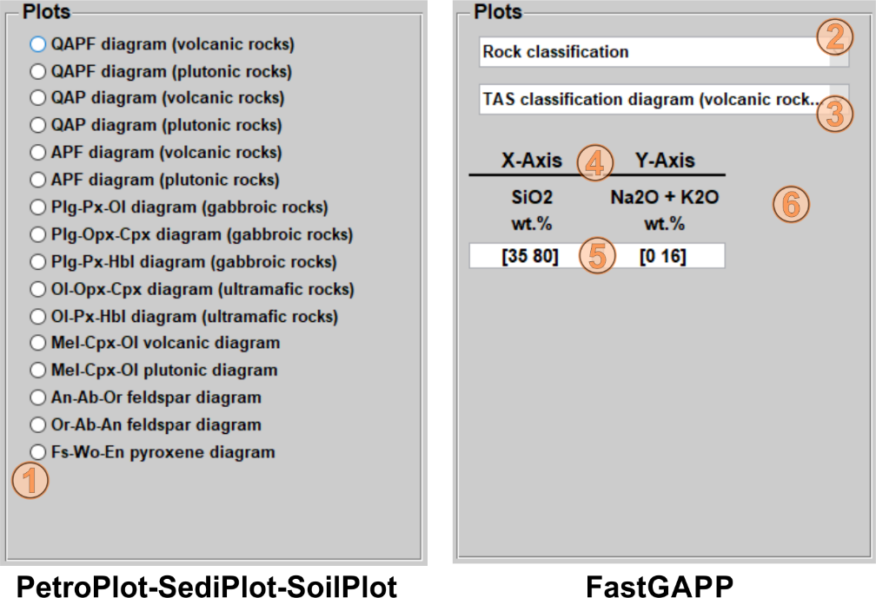Fig. 4.7‑1: Screenshots of the plot selection panels of the type 2 main window (left, PetroPlot, SediPlot and SoilPlot) and type 1 main window (right, FastGAPP).

More options are present in the plot selection panel of the type 1 main window (FastGAPP). Moreover, two popups, an axis overview, and the axis limits in an editable box allow to change an adjust the plots (Fig. 4.7-1). Plots for FastGAPP were roughly subdivided into ‘Rock classification’ and ‘Geotectonic discrimination’ for different kinds of rocks. By new selection, the upper popup changes the available plots in the lower popup. The final plot selection can be done by clicking and selecting any plot in the lower popup. FastGAPP does not have any auto-update function. The ‘Update’ button in the plot options panel will change its color to orange (see section 4.8). Click on the ‘Update’ button to refresh the plot preview. The axes information is automatically updated after a new plot has been selected (Fig. 4.7-1). Axes information include the headers and units for the currently selected plot. The editable text fields below the axis information shows the current axis limits. Editing one of the fields allows to change and adjust the plot linear, semi-logarithmic or logarithmic plots. Insert new values to change the axis limitations in the same style as it is already in the fields. Error messages will inform of the input was not correct. For triangle plots, information for the z-axis will also appear. Axis limits cannot be adjusted for triangle plots.

Please note that field labels for all plots are adjusted and positioned to fit within the axis limits of the original plots. If axes limits are adjusted, the field labels may be partially out of the fields and rotated labels may not be parallel to specific division lines anymore.

## Plot Options panel, Plot Preview and the Final Plot

### The Plot Options panel

After the datasets have been checked and the marker / labels and plots have been adjusted, the data is ready for plotting. This can be done by using the plot options panel. This panel consists of five buttons (Fig. 4.8-1). The ‘Plot’ button opens a new window with the final plot. The ‘Update’ button refreshes the plot preview in the center of the main windows. The ‘Clear’ button resets the plot preview and plot selection panel. The ‘Export PNG’ and ‘Export EPS’ buttons allow to save the current plot as raster image in portable network graphics format (.png) or vector graphics format (.eps).

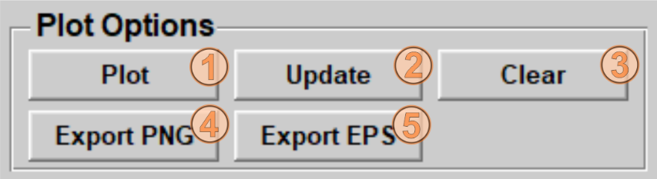

Fig. 4.8‑1: Screenshot of the plot options panel. The panel consists of five buttons. (1) The ‘Plot’ button opens a new window with the final plot, (2) the ‘Update’ button updates the plot preview, (3) the ‘Clear’ button clears the plot preview and resets the plot selection panel. Note that several functions the type 2 main window (PetroPlot, SediPlot, and SoilPlot) have an auto-update function. If the auto-update does not apply the ‘Update’ button (2) color changes to orange to indicate that the ‘Update’ button needs to be clicked to apply the updates. The ‘Export PNG’ (4) and ‘Export EPS’ (5) buttons allow to save the current plot as raster image in portable network graphics formats (.png) or vector graphics format (.eps).

### The Plot Preview

The plot preview gives an overview about the currently selected plot and data. The preview (i.e., marker sizes, line thicknesses, label sizes) is scaled down by a factor of 0.6 compared to the final plot.

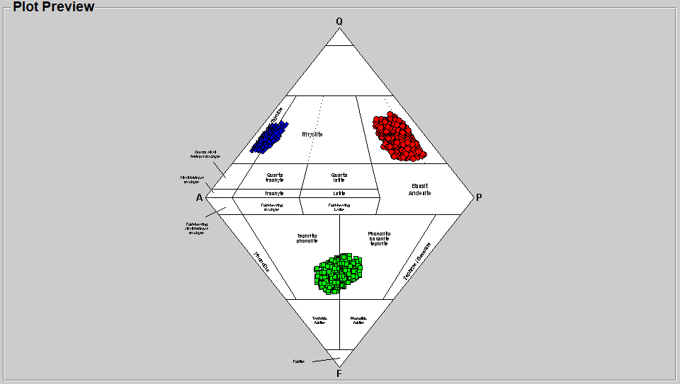

Fig. 4.8‑2: Screenshot of the plot preview panel with example data in QAPF diamond plot. Please note that the marker sizes, line thicknesses and label sizes are scaled down by a factor of 0.6 for the preview.

The plot preview can be refreshed by using the ‘Update’ button in the plot options panel (Fig. 4.8-1). In the type 2 main window (PetroPlot, SediPlot, SoilPlot), the plot selection panel has an auto-update function if the plot is changed, whereas plot changes in the type 1 main window for FastGAPP need to be done by clicking the ‘Update’ button as indicated by its orange color. In both main window types any changes of the plot / marker / label styles also have to be manually confirmed by clicking the orange ‘Update’ button once.

### The final plot

After clicking on the ‘Plot’ button a new window with the final plot opens (Fig. 4.8-3). In this window, all elements of the final plots can be manually adjusted (if necessary) and the plot can be exported into established raster or vector graphics formats. Click on ‘File’ (1) and then on ‘Export Setup…’ to open the export menu. Have a look through this menu and configure the export setup. Finally, click on ‘Export…’ to select the folder, filename and file type for the output graphics.

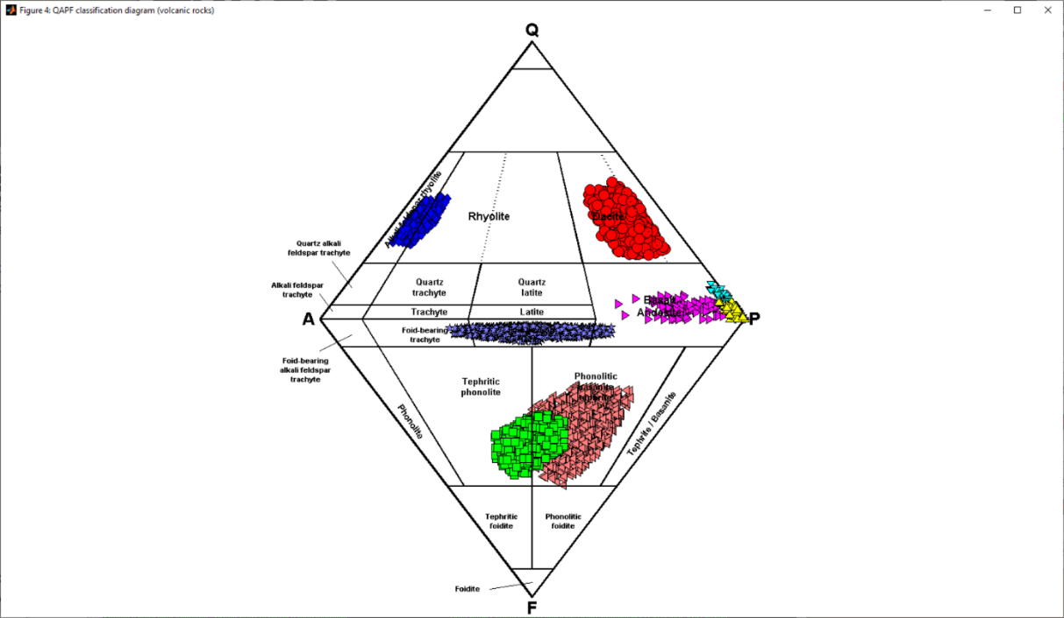

Fig. 4.8‑3: Screenshot of the final QAPF plot in a new window. MATLAB has several functions to export the plot in established raster or vector graphics format. Click on ‘File’ (1) and then on ‘Export Setup…’ to open the export menu, adjust the export options and click on ‘Export…’ to select the folder, export filename and file type.

## Saving / Loading Markers and Saving Sessions

One editable field and three black buttons are present on the upper black bar of the main windows right of the program name (Figs. 4.0-1, 4.9-1).

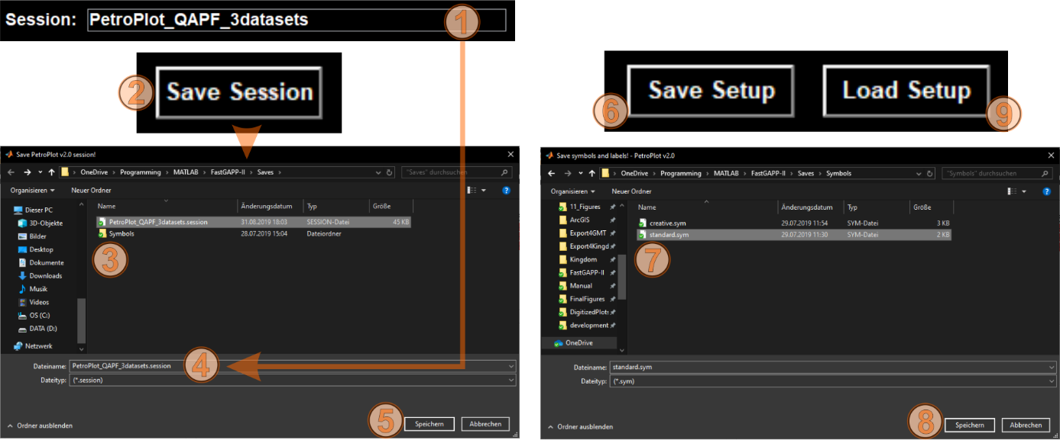

Fig. 4.9‑1: Screenshots of the ‘Save Setup’ (1), ‘Load Setup’ (2) and ‘Save Session’ (5) buttons. Clicking of the ‘Save Setup’ button will open a file selection window where an output ‘.sym’ file has be selected and overwritten or created with a new file name (2). Clicking on the ‘Save’ button (3) will store the ‘.sym’ file. The ‘.sym’ comprises the current marker / label and plot line / label setups. The created file can be loaded into any session (also in other programs) afterwards by using the ‘Load Setup’ button and select it in the new file selection window. The workflow with ‘Save Session’ button is the same, but additionally the current loaded datasets are also saved. Click the ‘Save Session’ button (5) and create a new or overwrite an existing ‘.session’ file (6) by clicking on the ‘Save’ button. This ‘.session’ file can be selected before starting any program (see section 3.1) by clicking the ‘Load Session’ button (see section 3.6).

The two buttons to the right allow to save and load the markers, labels and plot setup (Fig. 4.9-1). Clicking on ‘Save Setup’ opens a standard file selection window for saving files (Fig. 4.9‑1). Select a file name in this window and click on save. The file extension for the saved setup file is ‘.sym’. Clicking on ‘Load Setup’ opens a standard file selection window where the saved ‘.sym’ setup files can be loaded again. Note that default markers and lines are always created for nine datasets while running any sub-program. For example: Importing three datasets only allows to change marker for these three datasets in this session. However, the default setups for dataset #4 - #9 are still loaded into the session and will be then also present in the saved ‘.sym’ file.

The editable field in the middle of the black bar allows to rename the current session. The entered name is also the default name for the saved session. Pressing the ‘Save Session’ button left of the ‘Save Setup’ and ‘Load Setup’ allows to save the whole session, which includes (I) the currently loaded datasets, (II) dataset marker / label setup, and (III) plot line / label setup. The file extension of saved sessions is ‘.session’. The ‘.session’ files can be loaded before any sub-program is started (see sections 3.1 and 3.6). Saved sessions can be only opened with the same programs in which it was saved.

# FastGAPP v2.0

FastGAPP reads geochemical (main and trace elemental) datasets from igneous rocks. Plot options include over 83 pre-defined classification and geotectonic discrimination diagrams. Moreover, it is possible to create elemental variations diagrams and typical rare-earth element or multi-element plots. Overall, FastGAPP supports 85 different headers values.

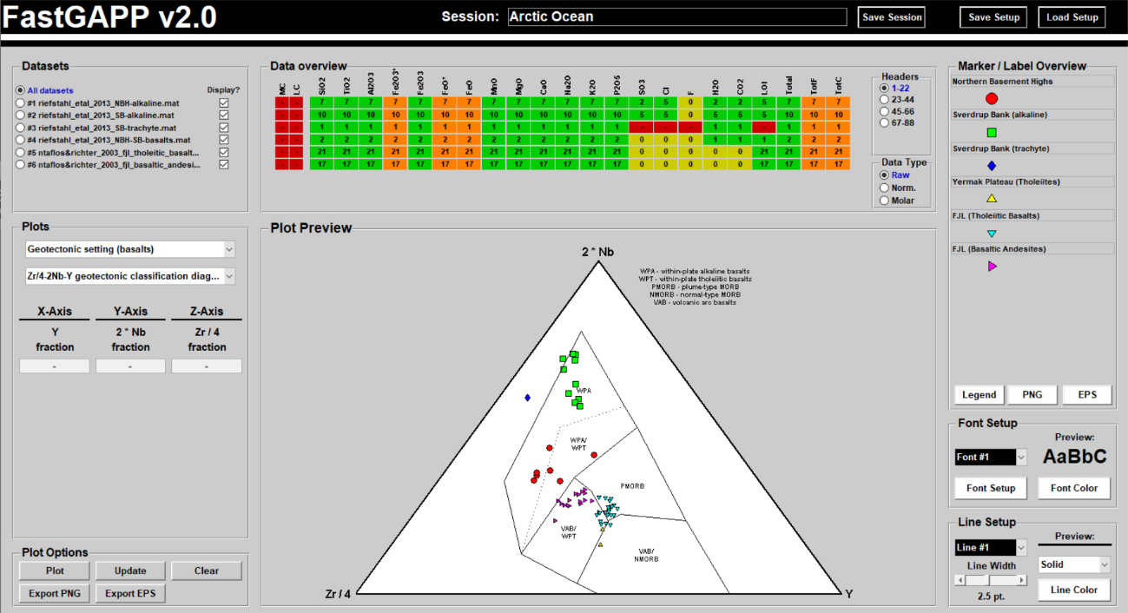

Fig. 4.9‑1: Screenshot of FastGAPP v2.0’s main window.

## Supported header values, units and internal storage

Valid header values for FastGAPP include 85 entries, which are listed in Tab. 5.1-1.

Tab. 5.1‑1: List of valid headers entries, their corresponding complete name, internal storage unit and valid input units

|  |  |  |  |
| --- | --- | --- | --- |
| Header entries  Oxide / Element | Name | Internal storage | Valid input units |
| SiO2 | silica | wt. % | wt. % |
| TiO2 | titania | wt. % | wt. % |
| Al2O3 | alumina | wt. % | wt. % |
| Fe2O3tot | total iron as iron 3 oxide | wt. % | wt. % |
| Fe2O3 | iron 3 oxide | wt. % | wt. % |
| FeOtot | total iron as iron 2 oxide | wt. % | wt. % |
| FeO | iron 2 oxide | wt. % | wt. % |
| MnO | manganese oxide | wt. % | wt. % |
| MgO | magnesia | wt. % | wt. % |
| CaO | calcium oxide | wt. % | wt. % |
| Na2O | sodium oxide | wt. % | wt. % |
| K2O | potassium oxide | wt. % | wt. % |
| P2O5 | phosphorus pentoxide | wt. % | wt. % |
| SO3 | sulphur trioxide | wt. % | wt. % |
| Cl | chlorine | wt. % | wt. % |
| F | fluorine | wt. % | wt. % |
| H2O | water / vapor | wt. % | wt. % |
| CO2 | carbon dioxide | wt. % | wt. % |
| LOI | loss-on-ignition | wt. % | wt. % |
| Total | total (input data) | wt. % | wt. % |
| TotF | total (volatile-free calculation) | wt. % | wt. % |
| TotC | total (calculated, all) | wt. % | wt. % |
| TotM | total (calculated, main elements and volatiles) | wt. % | wt. % |
| TotT | total (calculated, trace elements) | wt. % | wt. % |

Tab. 5.1-1: (continued)

|  |  |  |  |
| --- | --- | --- | --- |
| Header entries  Oxide / Element | Name | Internal storage | Valid input units |
| Ag | silver | ppm | ppm, ppb |
| As | arsenic | ppm | ppm, ppb |
| Au | gold | ppm | ppm, ppb |
| B | boron | ppm | ppm, ppb |
| Ba | barium | ppm | ppm, ppb |
| Be | beryllium | ppm | ppm, ppb |
| Bi | bismuth | ppm | ppm, ppb |
| Cd | cadmium | ppm | ppm, ppb |
| Co | cobalt | ppm | ppm, ppb |
| Cr | chromium | ppm | ppm, ppb |
| Cs | caesium | ppm | ppm, ppb |
| Cu | copper | ppm | ppm, ppb |
| Ga | gallium | ppm | ppm, ppb |
| Ge | germanium | ppm | ppm, ppb |
| Hf | hafnium | ppm | ppm, ppb |
| Hg | mercury | ppm | ppm, ppb |
| In | indium | ppm | ppm, ppb |
| Li | lithium | ppm | ppm, ppb |
| Mo | molybdenum | ppm | ppm, ppb |
| Nb | niobium | ppm | ppm, ppb |
| Ni | nickel | ppm | ppm, ppb |
| Pb | lead | ppm | ppm, ppb |
| Rb | rubidium | ppm | ppm, ppb |
| Re | rhenium | ppm | ppm, ppb |
| Sb | antimony | ppm | ppm, ppb |
| Sc | scandium | ppm | ppm, ppb |
| Se | selenium | ppm | ppm, ppb |
| Sn | tin | ppm | ppm, ppb |
| Sr | strontium | ppm | ppm, ppb |
| Ta | tantalum | ppm | ppm, ppb |
| Te | tellurium | ppm | ppm, ppb |
| Th | thorium | ppm | ppm, ppb |
| Tl | thallium | ppm | ppm, ppb |
| U | uranium | ppm | ppm, ppb |
| V | vanadium | ppm | ppm, ppb |
| W | tungsten | ppm | ppm, ppb |
| Y | yttrium | ppm | ppm, ppb |
| Zn | zinc | ppm | ppm, ppb |
| Zr | zirconium | ppm | ppm, ppb |
| Ru | ruthenium | ppm | ppm, ppb |
| Rh | rhodium | ppm | ppm, ppb |
| Pd | palladium | ppm | ppm, ppb |
| Os | osmium | ppm | ppm, ppb |
| Ir | iridium | ppm | ppm, ppb |
| Pt | platinum | ppm | ppm, ppb |
| La | lanthanum | ppm | ppm, ppb |
| Ce | cerium | ppm | ppm, ppb |
| Pr | praseodymium | ppm | ppm, ppb |
| Nd | neodymium | ppm | ppm, ppb |
| Sm | samarium | ppm | ppm, ppb |
| Eu | europium | ppm | ppm, ppb |
| Gd | gadolinium | ppm | ppm, ppb |
| Tb | terbium | ppm | ppm, ppb |
| Dy | dysprosium | ppm | ppm, ppb |
| Ho | holmium | ppm | ppm, ppb |
| Er | erbium | ppm | ppm, ppb |
| Tm | thulium | ppm | ppm, ppb |
| Yb | ytterbium | ppm | ppm, ppb |
| Lu | lutetium | ppm | ppm, ppb |

## Calculations

Beside the import of the input data, FastGAPP performs several calculations with some header entries. These additional calculations are listed below.

### Fe2O3, FeO, Fe2O3 total and FeO total

Heterogenous input datasets are supported since calculations are performed sample-wise. Although not recommended, it is possible that the input files contain numeric values for all four headers. FastGAPP parses through all samples of the input datasets and checks if numeric data are available below these four header entries. Several cases are possible:

1) All four headers are defined: FastGAPP assumes that the given input data are already correctly calculated in the input. No further calculation will be performed by FastGAPP.

2) Only FeO or only Fe2O3 have numeric data: FastGAPP assumes that the given header is the total value. If only Fe2O3 is given, then this will also be the Fe2O3 total. FeO and Fetotal will be calculated from Fe2O3 and Fe2O3 total, respectively.

3) Both, FeO and Fe2O3 have numeric data. Fe2O3 total will be calculated from the sum of FeO * 0.8998 and Fe2O3. Fetotal will be in turn calculated from Fe2O3 total.

### Normalization to 100 wt.%

After the calculation of iron contents, FastGAPP performs a volatile-free normalization to 100 wt.% for all datasets. This is required to plot the geochemical data in e.g. the TAS diagrams. Total values are calculated for different configurations (see Tab. 5.1-1). For the normalization to 100 wt. %, FastGAPP uses the calculated TotF value. Accordingly, F, Cl SO3, H2O, and CO2, loss-on-ignition (LOI) are neglected during the normalization. The normalization is based on the Fe2O3 total iron contents. FeO contents are still shown in the normalized data, but these are calculated from the Fe2O3 contents.

### Molar conversion

Furthermore, FastGAPP converts the input data to mol. %. Molar weights are taken from the integrated elements database (see section 10). Afterwards, the input data is normalized to 100 mol. %.

### Other calculated parameters

Broadly used indices are calculated after the input data processing explained above. These are attached at the end of valid headers and, therefore, are shown after the last valid header entry ‘Lu’ in the data overview panel. FastGAPP calculates the alumina saturation index (ASI), the peraluminty index (PI), agpaitic index (AI) and the modified alkali lime index (MALI), which are defined as:

PI = molar Al / (Na + K)

ASI = molar Al / (Na + K + (Ca - 1.67 * P))

AI = molar (Na + K) / Al

MALI = wt.% Na2O + K2O - CaO

## Contained plots

FastGAPP v2.0 contains 83 plots. All plots with their corresponding reference are listed in Tab. 5.3-1.

Tab. 5.3‑1: List of the 83 plots contained in FastGAPP v2.0.

|  |  |  |  |
| --- | --- | --- | --- |
| Plot Title | Purpose | Plot type | Reference |
| TAS classification diagram (volcanic rocks I) | Rock classification (all) | linear | Le Bas et al. (1986) |
| TAS (discrimination line I) | Rock classification (all) | linear | MacDonald (1968) |
| TAS (discrimination line II) | Rock classification (all) | linear | Irvine & Baragar (1971) |
| TAS classification diagram (volcanic rocks II) | Rock classification (all) | linear | Middlemost (1994) |
| TAS classification diagram (plutonic rocks) | Rock classification (all) | linear | Middlemost (1994) |
| TAS classification diagram (volcanic pebbles) | Rock classification (all) | linear | Cox et al. (1979) |

Tab. 5.3-1: (continued)

|  |  |  |  |
| --- | --- | --- | --- |
| Plot Title | Purpose | Plot type | Reference |
| SiO2 vs. Zr/TiO2 classification diagram | Rock classification (all) | semi-log.x | Winchester & Floyd (1977) |
| SiO2 vs. Nb/Y classification diagram | Rock classification (all) | semi-log.x | Winchester & Floyd (1977) |
| Zr/TiO2 vs. Nb/Y classification diagram | Rock classification (all) | loglog | Winchester & Floyd (1977) |
| Na2O vs. K2O classification diagram | Rock classification (all) | linear | Middlemost (1994) |
| AFM classification diagram | Rock classification (all) | ternary | Irvine & Baragar (1971) |
| Peraluminity Index vs. Alkalinity Saturation Index | Rock classification (all) | linear | Shand (1927), Shand (1943) |
| FeOtot/(MgO+FeOtot) discrimination diagram | Rock classification (all) | linear | Frost & Frost (2008) |
| MALI vs. SiO2 discrimination diagram | Rock classification (all) | linear | Frost & Frost (2008) |
| Alkalinity Saturation Index vs. SiO2 | Rock classification (all) | linear | Frost & Frost (2008) |
| Peraluminity Index vs. SiO2 | Rock classification (all) | linear | Frost & Frost (2008) |
| Sr/Y vs. Y classification diagram | Rock classification (all) | linear | Hansen et al. (2002) |
| P2O5 vs. Zr discrimation diagram | Rock classification (basalts) | linear | Floyd & Winchester (1975) |
| TiO2 vs. Zr/P2O5 discrimation diagram | Rock classification (basalts) | linear | Floyd & Winchester (1975) |
| Nb/Y vs. Zr/P2O5 discrimation diagram | Rock classification (basalts) | linear | Floyd & Winchester (1975) |
| K2O vs. SiO2 classification diagram | Rock classification (subd.-rel.) | linear | Peccerillo and Taylor (1976) |
| Th vs. Co classification diagram | Rock classification (subd.-rel.) | semi-log.y | Hastie et al. (2007) |
| FeOtotal / MgO vs. SiO2 classification diagram | Rock classification (subd.-rel.) | linear | Miyashiro (1974) |
| FeOtotal vs. FeOtotal / MgO classification diagram | Rock classification (subd.-rel.) | linear | Miyashiro & Shido (1975) |
| TiO2 vs. FeOtotal / MgO classification diagram | Rock classification (subd.-rel.) | semi-log.y | Miyashiro & Shido (1975) |
| V vs. FeOtotal / MgO classification diagram I | Rock classification (subd.-rel.) | semi-log.y | Miyashiro & Shido (1975) |
| V vs. FeOtotal / MgO classification diagram II | Rock classification (subd.-rel.) | semi-log.y | Miyashiro & Shido (1975) |
| Cr vs. SiO2 classification diagram | Rock classification (subd.-rel.) | semi-log.y | Miyashiro & Shido (1975) |
| V vs. Cr classification diagram | Rock classification (subd.-rel.) | loglog | Miyashiro & Shido (1975) |
| CaO/(Na2O+K20) vs. SiO2 discrimination diagram | Rock classification (subd.-rel.) | semi-log.y | Brown (1982) |
| Na2O + K2O vs. 10000*Ga/Al granite subdivision | Rock classification (granitic) | semi-log.x | Whalen et al. (1987) |
| (Na2O + K2O) / CaO vs. 10000*Ga/Al granite subdivision | Rock classification (granitic) | loglog | Whalen et al. (1987) |
| K2O / MgO vs. 10000*Ga/Al granite subdivision | Rock classification (granitic) | loglog | Whalen et al. (1987) |
| FeOtotal / MgO vs. 10000*Ga/Al granite subdivision | Rock classification (granitic) | loglog | Whalen et al. (1987) |
| Zr vs. 10000*Ga/Al granite subdivision | Rock classification (granitic) | loglog | Whalen et al. (1987) |
| Nb vs. 10000*Ga/Al granite subdivision | Rock classification (granitic) | loglog | Whalen et al. (1987) |
| Ce vs. 10000*Ga/Al granite subdivision | Rock classification (granitic) | loglog | Whalen et al. (1987) |
| Y vs. 10000*Ga/Al granite subdivision | Rock classification (granitic) | loglog | Whalen et al. (1987) |
| Zn vs. 10000*Ga/Al granite subdivision | Rock classification (granitic) | loglog | Whalen et al. (1987) |
| AI vs. 10000*Ga/Al granite subdivision | Rock classification (granitic) | semi-log.x | Whalen et al. (1987) |
| FeOtot / MgO vs. Zr+Nb+Ce+Y granite subdivision | Rock classification (granitic) | loglog | Whalen et al. (1987) |
| (Na2O + K2O) / CaO vs. Zr+Nb+Ce+Y granite subdivision | Rock classification (granitic) | loglog | Whalen et al. (1987) |
| Rb/Nb vs. Y/Nb granite subdivision | Rock classification (granitic) | loglog | Eby (1992) |
| Y/Nb vs. Sc/Nb granite subdivision | Rock classification (granitic) | loglog | Eby (1992) |
| Nb-Y-Ga A-type gra nite subdivision | Rock classification (granitic) | ternary | Eby (1992) |
| Nb-Y-Ce A-type granite subdivision | Rock classification (granitic) | ternary | Eby (1992) |
| Ga/Al vs. Eu/Eu* granite subdivision | Rock classification (granitic) | linear | Eby (1992) |
| Yb vs. Al2O3 granite subdivision | Rock classification (granitic) | semi-log.y | Arth (1979) |

Tab. 5.3-1: (continued)

|  |  |  |  |
| --- | --- | --- | --- |
| Plot Title | Purpose | Plot type | Reference |
| Carbonatite classification diagram I | Rock classification (carbonatites) | ternary | LeBas & Streckeisen (1991) |
| Carbonatite classification diagram II | Rock classification (carbonatites) | ternary | Gittins & Harmer (1997) |
| Th/Ta vs. Yb geotectonic discrimination diagram | Geotectonic setting (all) | linear | Gorton & Schandl (2000) |
| Th/Yb vs. Ta/Yb geotectonic discrimination diag. | Geotectonic setting (all) | loglog | Gorton & Schandl (2000) |
| MnO-TiO2-P2O5 geotectonic discrimination diag. | Geotectonic setting (basalts) | ternary | Mullen (1983) |
| TiO2-K2O-P2O5 geotectonic discrimination diag. | Geotectonic setting (basalts) | ternary | Pearce et al. (1975) |
| Al2O3-FeO-MgO geotectonic discrimination diag. | Geotectonic setting (basalts) | ternary | Pearce et al. (1977) |
| Zr/Nb vs. Nb/Th geotectonic discrimination diag. | Geotectonic setting (basalts) | semi-log.y | Condie (2003) |
| Nb/Y vs. Zr/Y geotectonic discrimination diagram | Geotectonic setting (basalts) | loglog | Condie (2003) |
| Nb/Y vs. Zr/Y source discrimination diagram | Geotectonic setting (basalts) | loglog | Fitton et al., 1997 |
| Zr/4-2Nb-Y geotectonic discrimination diagram | Geotectonic setting (basalts) | ternary | Meschede (1986) |
| Ti vs Zr geotectonic discrimination diagram | Geotectonic setting (basalts) | linear | Pearce & Cann (1973) |
| Sr/2-Ti/100-Zr geotectonic discrimination diag. | Geotectonic setting (basalts) | ternary | Pearce & Cann (1973) |
| Ti/100-3Y-Zr geotectonic discrimination diagram | Geotectonic setting (basalts) | ternary | Pearce & Cann (1973) |
| Ta-Th-Hf/3 geotectonic discrimination diagram | Geotectonic setting (basalts) | ternary | Wood (1980) |
| Nb/8-La/10-Y/15 geotectonic discrimination diag. | Geotectonic setting (basalts) | ternary | Cabanis & Lecolle (1989) |
| Nb/La vs. La/Yb geotectonic discrimination diag. | Geotectonic setting (basalts) | loglog | Hollocher et al. (2012) |
| 17.9*Ta/La vs. La/Yb geotectonic discrimin. diag. | Geotectonic setting (basalts) | loglog | Hollocher et al. (2012) |
| ((Nb+17.9*Ta)/2)/La vs. La/Yb geot. discr. diag. | Geotectonic setting (basalts) | loglog | Hollocher et al. (2012) |
| Th/La vs. La/Yb geotectonic discrimination diag. | Geotectonic setting (basalts) | loglog | Hollocher et al. (2012) |
| V vs. Ti discrimination diagram | Geotectonic setting (basalts) | linear | Shervais (1982) |
| Cr vs. Ti discrimination diagram | Geotectonic setting (basalts) | loglog | Pearce (1975) |
| Cr vs. Y discrimination diagram | Geotectonic setting (basalts) | loglog | Dilek et al. (2007) |
| Zr vs. Ti discrimination diagram | Geotectonic setting (basalts) | linear | Dilek & Furnes (2007) |
| Zr/Y vs. Zr discrimination diagram I | Geotectonic setting (basalts) | loglog | Pearce & Norry (1979) |
| Ti vs. Zr discrimination diagram I | Geotectonic setting (basalts) | loglog | Pearce et al. (1981) |
| K2O/Yb vs. Ta/Yb discrimination diagram | Geotectonic setting (basalts) | loglog | Pearce (1982) |
| Th/Yb vs. Ta/Yb discrimination diagram II | Geotectonic setting (basalts) | loglog | Pearce (1982) |
| Ti/Y vs. Nb/Y discrimination diagram | Geotectonic setting (basalts) | loglog | Pearce (1982) |
| Th/Yb vs. Ta/Yb discrimination diagram III | Geotectonic setting (basalts) | loglog | Pearce (1983) |
| Zr/Y vs. Zr discrimination diagram II | Geotectonic setting (basalts) | loglog | Pearce (1983) |
| Rb vs. Y + Nb discrimination diagram | Geotectonic setting (granitic) | loglog | Pearce et al. (1984) |
| Rb vs. Yb + Ta discrimination diagram | Geotectonic setting (granitic) | loglog | Pearce et al. (1984) |
| Nb vs. Y discrimination diagram | Geotectonic setting (granitic) | loglog | Pearce et al. (1984) |
| Yb vs. Ta discrimination diagram | Geotectonic setting (granitic) | loglog | Pearce et al. (1984) |

## PLOT-O-MAT – Plotting of elemental variation diagrams

The PLOT-O-MAT v2.0 graphical user interface allows to create linear, semi-logarithmic and logarithmic plots and variation diagrams. To start the PLOT-O-MAT, select ‘PLOT-O-MAT’ in the first popup of the plot selection panel in FastGAPP’s main window (Fig. 5.4-1). A large button ‘Start PLOT-O-MAT’ appears and other control elements disappear in the plot selection panel or are disabled in the plot options panel. Click on the button to start the PLOT-O-MAT graphical user interface.

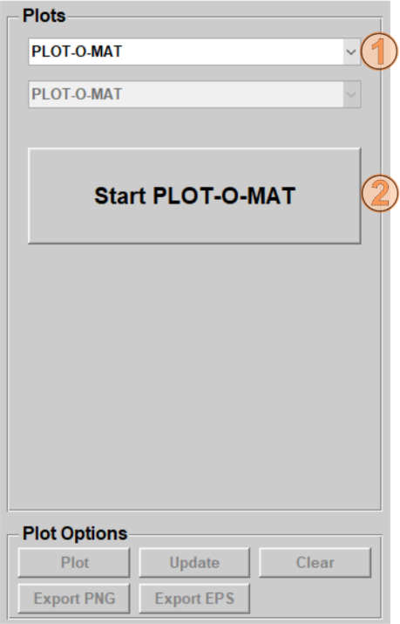Fig. 5.4‑1: Screenshot of the plot selection window. Use the first popup (1) to select the PLOT-O-MAT. All other control elements disappear and a new button ‘Start PLOT-O-MAT’ (2) appears in the plot selection window. Click on that button (2) to start the PLOT-O-MAT graphical user interface.

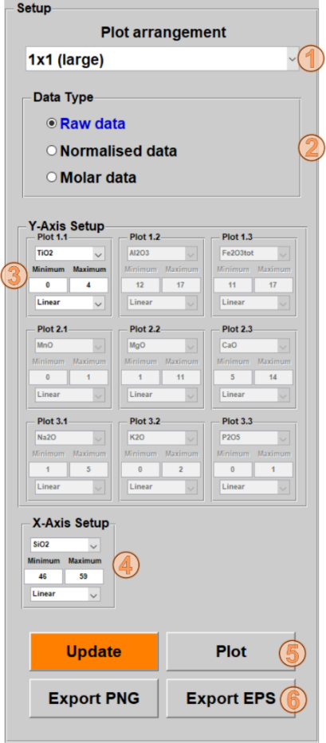Fig. 5.4‑2: Screenshot of the setup panel of the PLOT-O-MAT graphical user interface. The setup panel contains a popup to select the plot arrangement (1), whereby options include a large plot (1x1 large) and several small same-sized plot arrangements with up to 3x3 plots. Data types (raw, normalized and molar data) can be selected by the radio buttons (2). Dependent on the current plot arrangement selection, control panels for each y-axis (3) are enabled or disabled. The popup allows to select the header value. Furthermore, the axis minimum / maximum can be adjusted by the editable fields. The second popup allows to select the axis type (linear or logarithmic). The same elements are also available for the x‑axis setup panel (4). The ‘Update’ and ‘Plot’ button allow to update the preview right of the setup panel (Fig. 5.4-3) or to display the selected plot setup in a figure, respectively.

The PLOT-O-MAT user interface consists of a setup panel on the left side (Fig. 5.4-2) and a large preview panel on the right side (Fig. 5.4-3). The plot arrangement popup in the setup panel (Fig. 5.4-2) allows to select different arrangements of the elements. Options include a larger single plot (1x1 large) or smaller same-sized plots (up to 3x3 = 9) plots. It is possible to select the data type (raw, normalized or molar data) by using the radio buttons in the data type panel (Fig. 5.4-2). Below the data type selection, several panels allow to adjust the y- and x-axis. Each panel includes (i) a popup to change the displayed header, (ii) editable fields for axis minimum and maximum, (iii) and a second popup to change the axis type (linear or logarithmic). Y-axis panels are disabled or enabled dependent on the currently selected plot arrangement. The editable fields allow numeric inputs only. The input in these fields is checked for consistency and error messages are generated if the input is invalid. If any new headers are selected, the corresponding axis limits will be automatically adjusted that the data is in view before updating the preview. The usage of the ‘Update’ (5) and ‘Plot’ (6) buttons (Figs. 5.4-2) is the same as in the main windows. Pressing the ‘Update’ button will show the current selection in the preview (Fig. 5.4-3) and clicking ‘Plot’ button will open a separate figure with the current selection. No automatic update function is implemented in the PLOT-O-MAT. If changes of the plot are done, the color of the ‘Update’ button changes to orange color to indicate that an update is required.

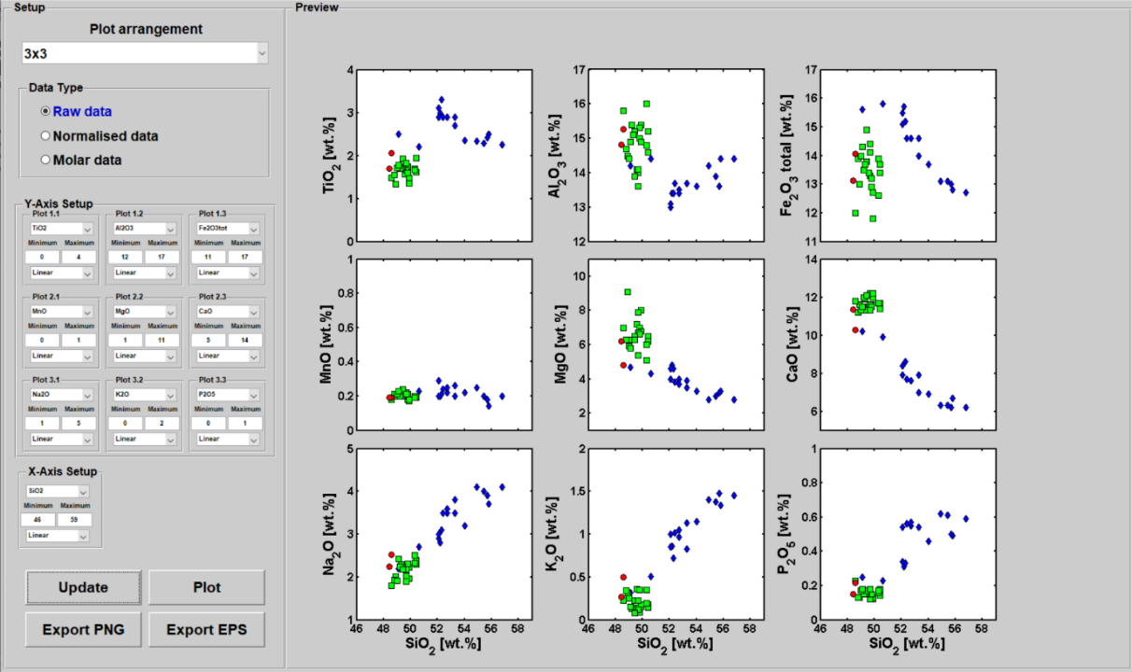

Fig. 5.4‑3: Screenshot of the PLOT-O-MAT graphical user interface. A 3x3 plot arrangement has been select with all main elements plotted over SiO2 from three datasets in linear plots. The displayed data is the raw input data.

## MULTIPL – The multi-element plotter

The MULTIPL v1.0 (MULTI-element PLotter) graphical user interface allows to create rare-earth element, spider, and multi-element plots. A database of several broadly used normalization values is included and will be loaded after starting MULTIPL. Select ‘MULTIPL’ in the upper popup of the plot selection panel in FastGAPP’s main window (Fig. 5.5-1). A large button ‘Start MULTIPLotter’ appears and other control elements disappear in the plot selection panel or are disabled in the plot options panel. Click on the button to start the PLOT-O-MAT graphical user interface.

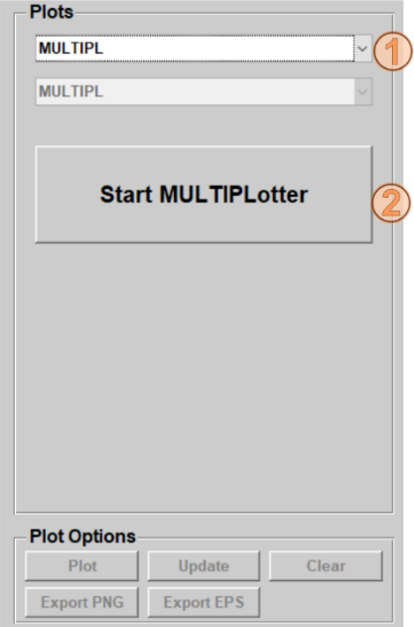Fig. 5.5‑1: Screenshot of the plot selection window. Use the first popup (1) to select the MULTIPL. All other control elements disappear and a new button ‘Start MULTIPLotter’ (2) appears in the plot selection window. Click on that button (2) to start the MULTIPL graphical user interface.

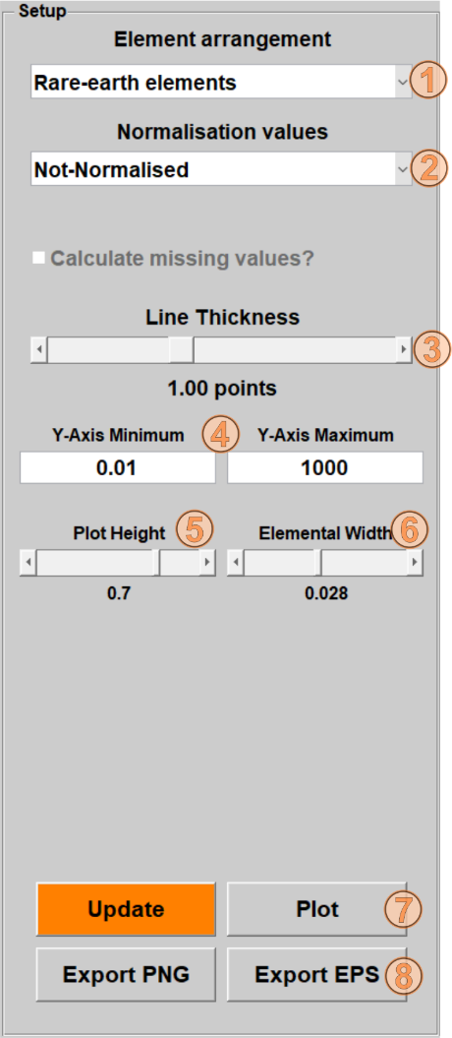Fig. 5.5‑2: Screenshot of the setup panel of the MULTIPL graphical user interface. The setup panel contains two popups. The first popup can be used to select the element arrangement (1), whereby options include rare-earth element and two multi-elemental arrangements. Normalization values can be selected by using the second popup (2). A slider (3) is integrated to adjust the thickness of the lines, which connect the plotted marker of the samples. The y-axis minimum / maximum can be adjusted by the editable fields (4). Only numeric input is allowed in these fields. Two other sliders are integrated, which allow to adjust the plot height (5) and width between the elements on the x-axis (6). The given units in (5) and (6) refer to normalized units relative to the size of the plot preview panel or final figure. The ‘Update’ and ‘Plot’ buttons (7) allows to update the preview right of the setup panel (Fig. 5.5-3) or to display the selected plot setup in a separate figure, respectively. The ‘Export PNG’ and ‘Export EPS’ (8) allow to export the final plot as raster image (.png) or vector graphics (.eps), respectively.

The MULTIPL user interface also consists of a setup panel on the left side (Fig. 5.5-2) and a preview panel on the right side (Fig. 5.5-3). Two popups (element arrangement and normalization values) are located on top of the setup panel (Fig. 5.5-2). Three different types of elemental arrangement can be selected by using the element arrangement popup: (i) rare-earth elements, (ii) spider diagrams containing few trace elements, (iii) and multi-element diagrams containing even more trace elements. By using the second popup the data can be normalized to the selected normalization values. Normalized element concentrations are connected by lines, which will have the same color as the marker face of this dataset (see section 4.5 how to change the marker color). The line thickness slider allows to adjust the thickness of the lines. Minimum and maximum of the y-axis can be adjusted by the two editable fields. These fields only allow numeric inputs. Several functions check the input in these fields and give error messages if the input was invalid.

Furthermore, two sliders are integrated to adjust the height of the plot (5) and width between each element. The values below this slider correspond to normalized units relative to the preview panel or the final plot. However, these sliders are integrated to adjust overly steep / flat curves and to keep the same elemental width for different elemental arrangements. The usage of the ‘Update’ and ‘Plot’ buttons is the same as in the main windows. Pressing the ‘Update’ button will show the current selection in the preview (Fig. 5.4-3) and clicking ‘Plot’ button will of a new figure with the current selection MULTIPL v1.0 does not contain an automatic update function. If anything of the plots is adjusted, the color of the ‘Update’ button changes to orange to indicate that an update is required.

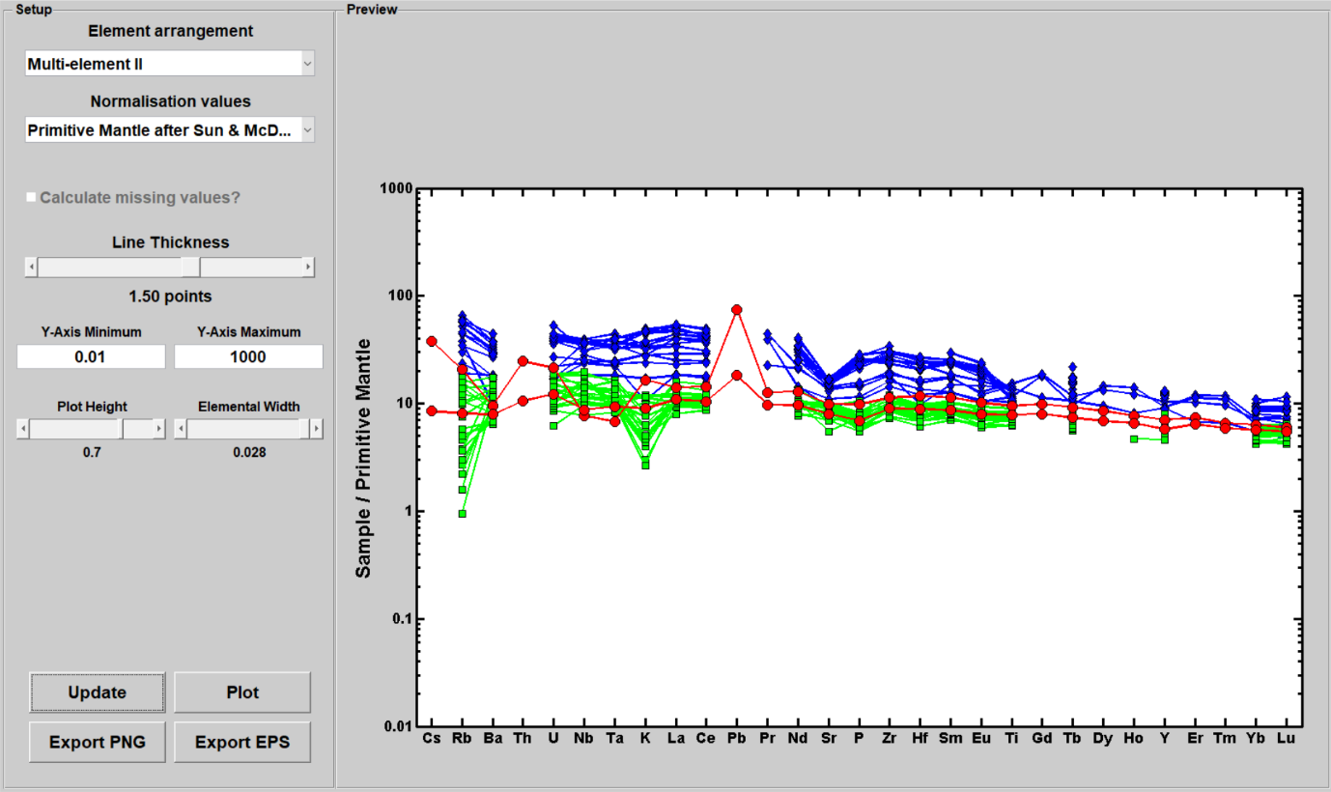

Fig. 5.5‑3: Screenshot of the MULTIPL v1.0 graphical user interface. The example data is arranged in a multi-element plot from incompatible to compatible elements normalized to primitive mantle (Sun & McDonough, 1989).

In the current version, the following normalization values are available:

* C1-chondrite (Sun and McDonough, 1989)
* Primitive mantle (Sun and McDonough, 1989)
* N-MORB – normal mid-ocean ridge basalts (Sun and McDonough, 1989)
* E-MORB – enriched mid-ocean ridge basalts (Sun and McDonough, 1989)
* OIB (Sun and McDonough, 1989)
* C1-chondrite (McDonough and Sun, 1995)
* Continental crust (Wedepohl, 1995)
* Tonalites (Wedepohl, 1995)
* Greywackes (Wedepohl, 1995)
* GLOSS - Global average subducted sediments (Plank and Langmuir, 1998)

If the normalization values from the literature do not contain a specific element, this element or these elements will not be shown on the x-axis! The database of normalization values can be easily enhanced (see section 11.3). Users are encouraged to share other normalization values in digital form with the developer to integrate these for future versions of FastGAPP.

Non-normalized elemental concentration can be also shown by using the ‘Normalization values’ popup (Fig. 5.5-2) and selecting ‘Not-Normalized’. Addtionally, MULTIPLE supports normalization of the input data on any sample from the input datasets (Fig. 5.5-4). To do that, use the ‘Normalization values’ popup and select ‘Select Sample’. A new window with the list of datasets appears. Select the dataset and click on ‘OK’. A second window appears with the list of samples contained in the selected dataset. Select the sample and click on ‘OK’. After updating the preview, all samples from all datasets are shown as normalized on this sample (Fig. 5.5-5). This will be also indicated with the y-axis label.

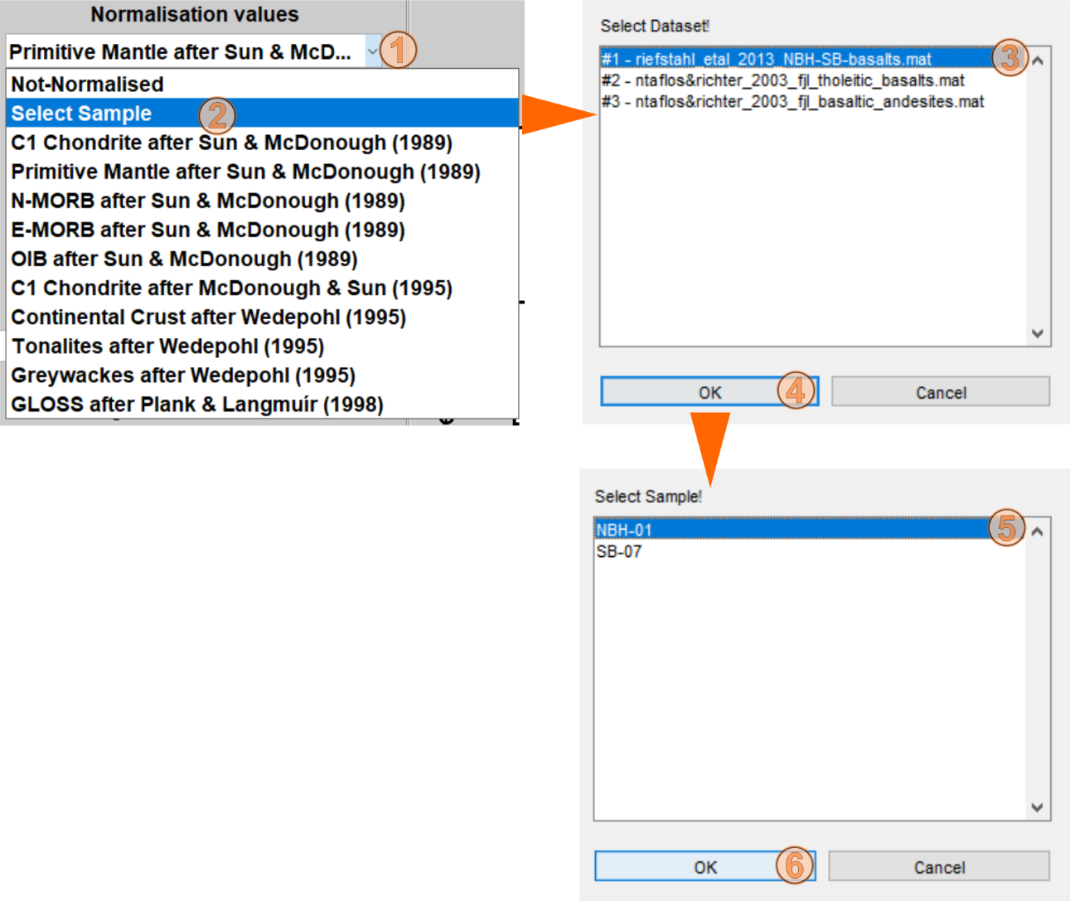

Fig. 5.5‑4: Screenshot of the normalization values popup to illustrate the workflow to normalize datasets on a specific sample. Click on the normalization values popup (1) and then select ‘Select Sample’ (2). Select a dataset from the list in the new window (3) and click on ‘OK’ (4). Finally, select a sample from the previously selected dataset (5) and click on ‘OK’ again (6). See Fig. 5.5-5 for the results.

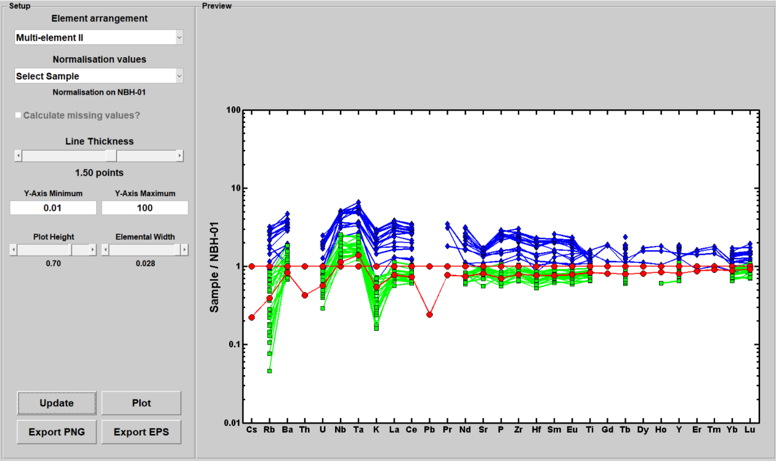

Fig. 5.5‑5: Screenshot of MULTIPL v1.0. The input data is arranged in a multi-element plot from incompatible to compatible elements normalized to specific sample (see Fig. 5.5-4 for the workflow).

# PetroPlot v2.0

PetroPlot imports petrographic data from igneous rocks. The petrographic data can be plotted in 16 classification diagrams. 13 diagrams are available for rocks classification (felsic-mafic-ultramafic and melilite-bearing rocks). Additionally, three diagrams allow mineral classifications.

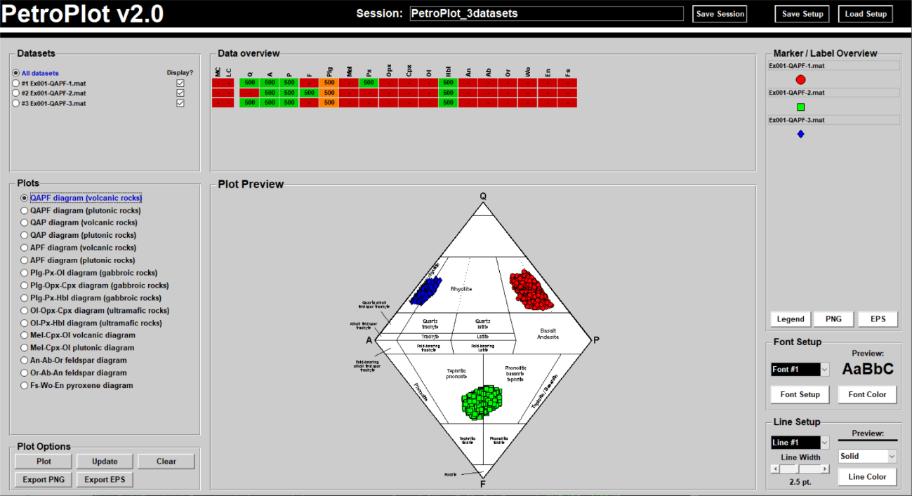

Fig. 5.5‑1: Screenshot of PetroPlot v2.0’s main window.

## Supported header values, units and internal storage

In this version PetroPlot v2.0 supports 20 different header values. These are listed in Tab. 6.1-1.

Tab. 6.1‑1: List of the valid header entries for PetroPlot v2.0.

|  |  |  |
| --- | --- | --- |
| Header Entry  Component | Header text | Valid Units /  Internal Storage |
| Q | Quartz | % |
| A | Alkali feldspar | % |
| P | Plagioclase | % |
| F | Feldspathoide | % |
| Plg | Plagioclase | % |
| Mel | Melilite | % |
| Px | Pyroxene | % |
| Opx | Orthopyroxene | % |
| Cpx | Clinopyroxene | % |
| Ol | Olivine | % |
| Hbl | Hornblende | % |
| An | Anorthite | % |
| Ab | Albite | % |
| Or | Orthoclase | % |
| Fo | Forsterite | % |
| Wo | Wollastonite | % |
| En | Enstatite | % |

## Calculations

Calculations performed by PetroPlot v2.0 are less complex as FastGAPP. It only handles headers, which are related to each other.

### P and Plg

These headers are generally the same component. PetroPlot uses both since QAPF diagrams use P and the gabbroic diagrams use Plg as the axis title. If one of these headers is available and the other is not, PetroPlot will copy these.

### Cpx, Opx, and Px

PetroPlot calculates the pyroxene (Px) contents from the orthopyroxene (Opx) and / or clinopyroxene (Cpx). If Px is not defined in the input file, but Opx or Cpx are given, PetroPlot calculates the sum of them.

## Contained plots

16 plots are available in PetroPlot. The plots and corresponding references are listed in Tab. 6.3-1.

Tab. 6.3‑1: List of plots contained in PetroPlot v2.0.

|  |  |  |  |
| --- | --- | --- | --- |
| Plot Title | Purpose | Plot Type | Reference |
| QAPF diagram (volcanic rocks) | rock classification | diamond | Le Maitre et al. (1989) |
| QAPF diagram (plutonic rocks) | rock classification | diamond | Le Maitre et al. (1989) |
| QAP diagram (volcanic rocks) | rock classification | ternary | Le Maitre et al. (1989) |
| QAP diagram (plutonic rocks) | rock classification | ternary | Le Maitre et al. (1989) |
| APF diagram (volcanic rocks) | rock classification | ternary inverted | Le Maitre et al. (1989) |
| APF diagram (plutonic rocks) | rock classification | ternary inverted | Le Maitre et al. (1989) |
| Plg-Px-Ol diagram (gabbroic rocks) | rock classification | ternary | Le Maitre et al. (1989) |
| Plg-Opx-Cpx diagram (gabbroic rocks) | rock classification | ternary | Le Maitre et al. (1989) |
| Plg-Px-Hbl diagram (gabbroic rocks) | rock classification | ternary | Le Maitre et al. (1989) |
| Ol-Opx-Cpx diagram (ultramafic rocks) | rock classification | ternary | Le Maitre et al. (1989) |
| Ol-Px-Hbl diagram (ultramafic rocks) | rock classification | ternary | Le Maitre et al. (1989) |
| Mel-Cpx-Ol diagram | rock classification | ternary | Le Maitre et al. (1989) |
| Mel-Cpx-Ol diagram | rock classification | ternary | Le Maitre et al. (1989) |
| An-Ab-Or feldspar diagram | mineral classification | ternary | Le Maitre et al. (1989) |
| Or-Ab-An feldspar diagram | granite classification | ternary | Barker (1979) |
| Fs-Wo-En pyroxene diagram | mineral classification | ternary | Morimoto (1988) |

# SediPlot v1.0

In contrast to PetroPlot, SediPlot v1.0 imports petrographic data from sedimentary rocks, primarily sandstone composition. Sandstone compositions can be plotted in 10 ternary classification and provenance analyses diagrams.

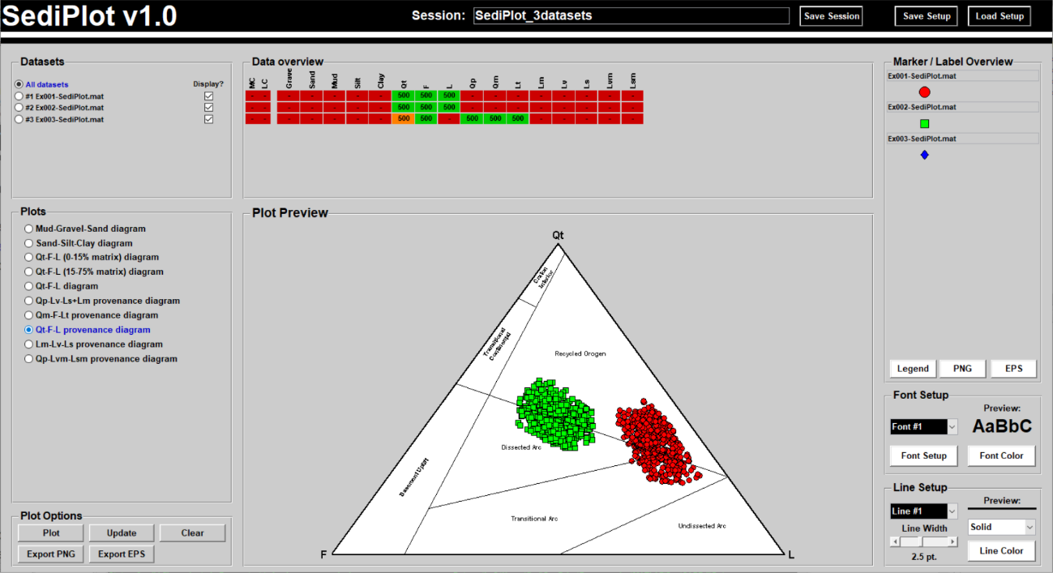

Fig. 6.3‑1: Screenshot of SediPlot v1.0’s main window.

## Supported header values, units and internal storage

SediPlot supports 16 different header entries, which are listed in Tab. 7.1-1.

Tab. 7.1‑1: List of the valid header entries for SediPlot v1.0.

|  |  |  |
| --- | --- | --- |
| **Header Entry**  **Component** | **Header text** | **Valid Units /**  **Internal Unit** |
| Gravel | > 2 mm | % |
| Sand | 2 - 0.063 mm | % |
| Mud | < 0.063 mm | % |
| Silt | 0.063 - 0.002 mm | % |
| Clay | < 0.002 mm | % |
| Qt | Quartz (total) | % |
| F | Feldspar | % |
| L | Lithic fragments | % |
| Qp | Quartz (polycrystalline) | % |
| Qm | Quartz (monocrystalline) | % |
| Lt | Total aphanitic lithic grains | % |
| Lm | Metamorphic aphanitic lithic grains | % |
| Lv | volcanic-hypabyssal aphanitic lithic grains | % |
| Ls | Sedimentary aphanitic grains | % |
| Lvm | Volcanic-hypabyssal and metavolcanic aphanitic lithic grains | % |
| Lsm | Sedimentary and metasedimentary lithic grains | % |

## Calculations

### Qt, Qm, and Qp

If the total quartz contents (Qt) are not defined in the input file, SediPlot calculates the Qt component from mono-crystalline quartz (Qm) and / or poly-crystalline quartz (Qp), if at least one of them is defined in the input file.

### Silt, Clay, and Mud

According to the classification scheme after Folk (1954), the component mud refers to all grains, which are smaller than 0.063 mm. Therefore, SediPlot calculates the mud component from given silt and clay components, if at least one of these components is available and the header mud has not been found in the input data.

## Contained plots

10 plots are available in this first version of SediPlot. These plots are listed in Tab 6.3-1 together with corresponding references.

Tab. 7.3‑1: List of plots contained in SediPlot v1.0.

|  |  |  |  |
| --- | --- | --- | --- |
| **Plot Title** | **Purpose** | **Plot Type** | **Reference** |
| Gravel-Mud-Sand classification diagram | sedimentary rocks classification | ternary | Folk (1954) |
| Sand-Silt-Clay diagram | sedimentary rocks classification | ternary | Folk (1954) |
| Qt-F-L sedimentary rocks classification diagram | sedimentary rocks (0-15% matrix) classification | ternary | Dott (1964), Pettijohn (1984) |
| Qt-F-L sedimentary rocks classification diagram | sedimentary rocks (15-75% matrix) classification | ternary | Dott (1964), Pettijohn (1984) |
| Qt-F-L sedimentary rocks classification diagram | sedimentary rocks classification | ternary | Folk (1965) |
| Qp-Lv-Ls+Lm provenance diagram | sediment provenance | ternary | Dickinson & Suczek (1979) |
| Qm-F-Lt provenance diagram | sediment provenance | ternary | Dickinson & Suczek (1979) |
| Qt-F-L provenance diagram | sediment provenance | ternary | Dickinson & Suczek (1979) |
| Lm-Lv-Ls provenance diagram | sediment provenance | ternary | Ingersoll & Suczek (1979) |
| Qp-Lvm-Lsm provenance diagram | sediment provenance | ternary | Ingersoll & Suczek (1979) |

# SoilPlot v1.0

In this new version of FastGAPP, the program SoilPlot v1.0 is introduced. The purpose of SoilPlot is to support the classification of soils based on the grain size. In this version, however, there is only 1 diagram for soil classification available.

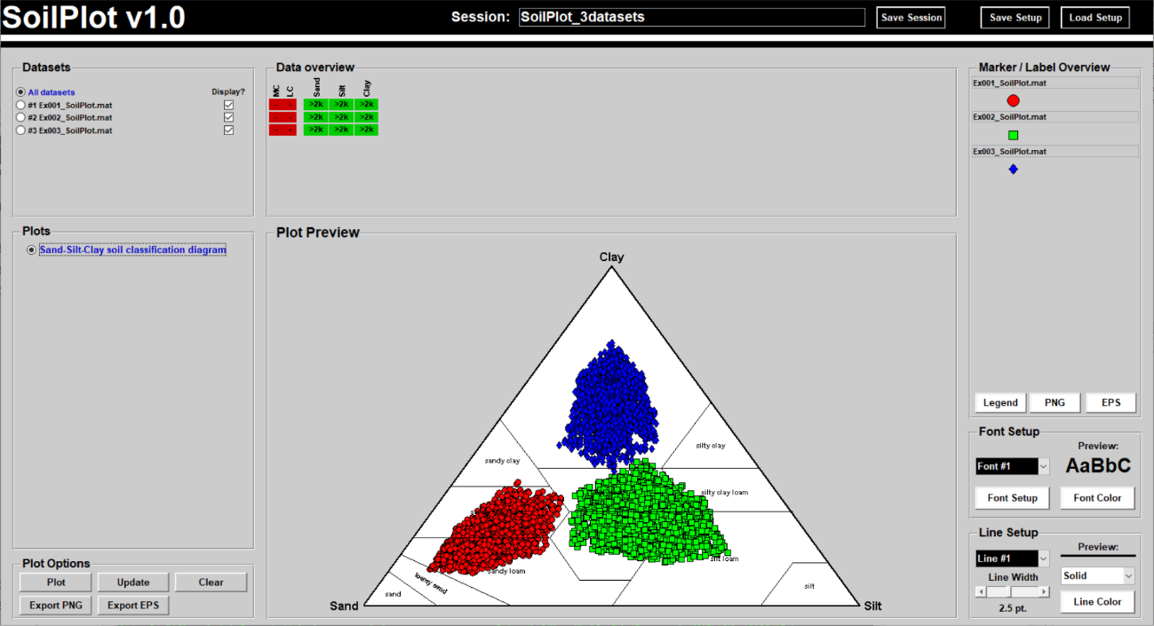

Fig. 7.3‑1: Screenshot of SoilPlot v1.0’s main window.

## Supported header values, units and internal storage

SoilPlot support three header entries, which are listed in Tab. 8.1-1.

Tab. 8.1‑1: List of the valid header entries for SoilPlot v1.0.

|  |  |  |
| --- | --- | --- |
| **Header Entry**  **Component** | **Header text** | **Valid Units /**  **Internal Unit** |
| Sand | 2 - 0.063 mm | % |
| Silt | 0.063 - 0.002 mm | % |
| Clay | < 0.002 mm | % |

## Calculations with header entries

No calculations are performed in SoilPlot v1.0.

## Contained plots

SoilPlot contain only one diagram, which is listed in Tab. 8.3-1 with its corresponding reference.

Tab. 8.3‑1: List of the contained plots in SoilPlot v1.0.

|  |  |  |  |
| --- | --- | --- | --- |
| **Plot Title** | **Purpose** | **Plot Type** | **Reference** |
| Sand-Silt-Clay soil classification diagram | Soil classification | ternary | USDA classification of soils |

# User-defined marker and labels

FastGAPP supports the input of user-defined marker and labels for all sub-programs. This feature may be important, if large datasets contain data from several publications / expeditions. Similar to the program-specific input header columns, the marker and label column need to be defined in the input dataset. Here, all header entries need to be present, else the definitions will not be imported into the sub-programs. The values and strings below need to be present for all samples.

## User-defined markers

Definition of marker requires 5 header columns with specific data types and formats. An example is shown in Fig. 9.1-1 and explained below:

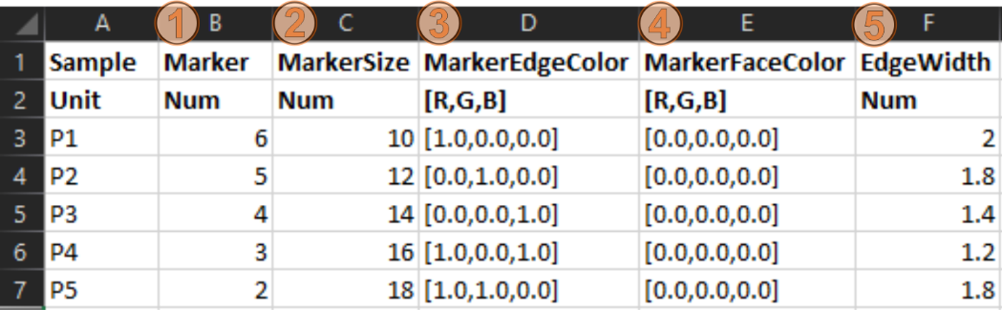

Fig. 9.1‑1: Screenshot of an example for correctly defined marker columns. Header words: (1) Marker, (2), MarkerSize, (3) MarkerEdgeColor, (4) MarkerFaceColor, (5) EdgeWidth. See text below for further explanations. Although units are listed in this screenshot, definition of units is not required to be given below the header words.

(1) Marker (numeric, 1-13). All standard markers available in MATLAB are also available for FastGAPP. 1 = circle, 2 = square, 3 = diamond, 4 = triangle, 5 = inverted triangle, 6 = right-directed triangle, 7 = left-directed triangle, 8 = pentagon, 9 = hexagon, 10 = plus sign, 11 = x-sign, 12 = star-sign, 13 = dot. Note that no marker face color can be defined for 10-13.

(2) MarkerSize (numeric in points). The marker size can be defined by a single number. Example: 12 = 12 points marker size. Values < 1 are invalid (and 1 is already very small).

(3) MarkerEdgeColor (normalized R,G,B). Marker edge color can be defined by using comma-separated normalized RGB triplets in square brackets. Examples: [1.0,0.0,0.0] = red, [0.0,1.0,0.0] = green, [0.0,0.0,1.0] = blue, [0.0,0.0,0.0] = black.

(4) MarkerFaceColor (normalized R,G,B). See marker edge color above.

(5) EdgeWidth (numeric in points). A single numeric value defines the width of the edge. 1 (point) is typical.

If all header columns are correctly defined in the input dataset, this will be indicated by a green boxes below the MC header (= Marker Columns) left of the program-specific header values in the data overview panel (Fig. 9.1-2). Present and activated user-defined markers will be also indicated in the marker / label overview panel (Fig. 9.1-2). However, it is possible to override the marker column in a session. If the marker / label setup panel is visible, a table shows the marker columns and an additional checkbox allows to switch to normal marker definition (Fig. 9.1-2). Nevertheless, unchecking the box will activate the marker columns again.

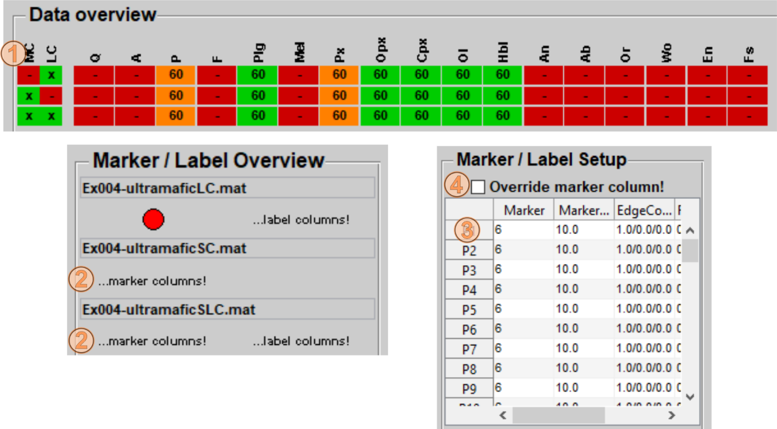

Fig. 9.1‑2: Screenshots of the data overview panel, marker / label overview panel and marker / label setup panels after input datasets contained valid marker columns. If correctly defined marker columns were present in the input file this will be indicated by the green boxes below the MC header (1). If marker columns are active, text is shown instead a single marker in the marker / label overview panel (2). A table with the marker columns (3) is shown in the marker / label setup panel. The checkbox (4) allows to override the marker columns and switch to normal marker definition.

## User-defined labels

Definition of label columns require 8 header columns with specific data types and formats below. An example is shown in Fig. 9.2-1.

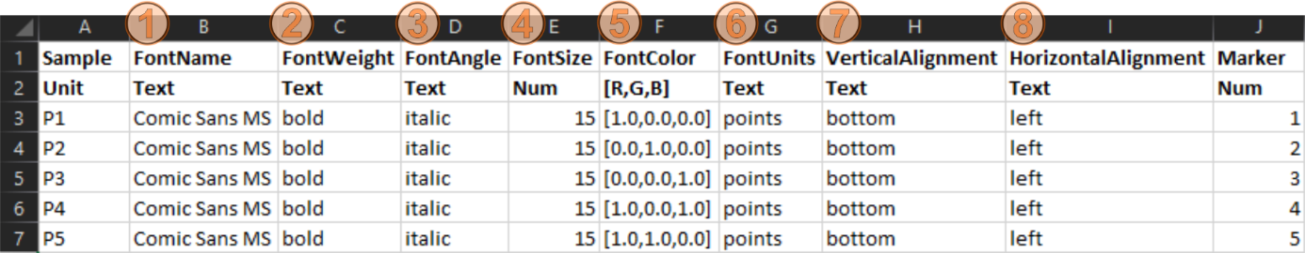

Fig. 9.2‑1: Screenshot of correctly defined label columns. Headers: (1) FontName, (2), FontWeight, (3) FontAngle, (4) FontSize, (5) FontColor, (6) FontUnits, (7) VerticalAlignment, (8) HorizontalAlignment. See text below for further explanations about the header words. Although units are listed in this screenshot, these are not required to be given below the header words.

1) FontName (text). Defines the font type. All system fonts are available. Type listfonts into the MATLAB command window to see a complete list of possible fonts. Example: Arial.

2) FontWeight (text). Possibilities are normal / bold / demi / light. Availability of demi and light is dependent on the defined font.

3) FontAngle (text). Options include normal / italic / oblique. Availability is dependent on the defined font.

4) FontSize (numeric). Defines the font size in font units (see point 6 below).

5) FontColor (normalized R,G,B). Font colors can be defined by using comma-separated normalized RGB triplets in square brackets. Examples: [1.0,0.0,0.0] = red, [0.0,1.0,0.0] = green, [0.0,0.0,1.0] = blue, [0.0,0.0,0.0] = black.

6) FontUnits (text). Definition of the font size units. Options include points / normalized / inches / centimeters / pixels. Usage of points is strongly recommended.

7) VerticalAlignment (numeric). Vertical placement of the text relative to the data point (sample). Options: Bottom / Baseline / Middle / Cap / Top. It is a broadly used convention that top means the text is placed below the data point and vice versa. Baseline and Cap place the letters indented to the specified y-position.

8) HorizontalAlignment (numeric). Horizontal placement of the text relative to the data point (sample). Options: Left / Center / Right. It is a broad used convention that left means the text is placed right of the data point and vice versa.

If all header columns are correctly defined, this will be indicated by the green box below the LC (= Label Columns) header left of the program-specific header values (Fig. 9.2-2). Furthermore, this will be also indicated in the marker / label overview panel (Fig. 9.2-2). Labels are automatically activated if label columns were found in the input file. It is also possible to override the label column in a session. If the marker / label setup is active an additional checkbox allows to switch to normal label definition (Fig. 9.2-2).

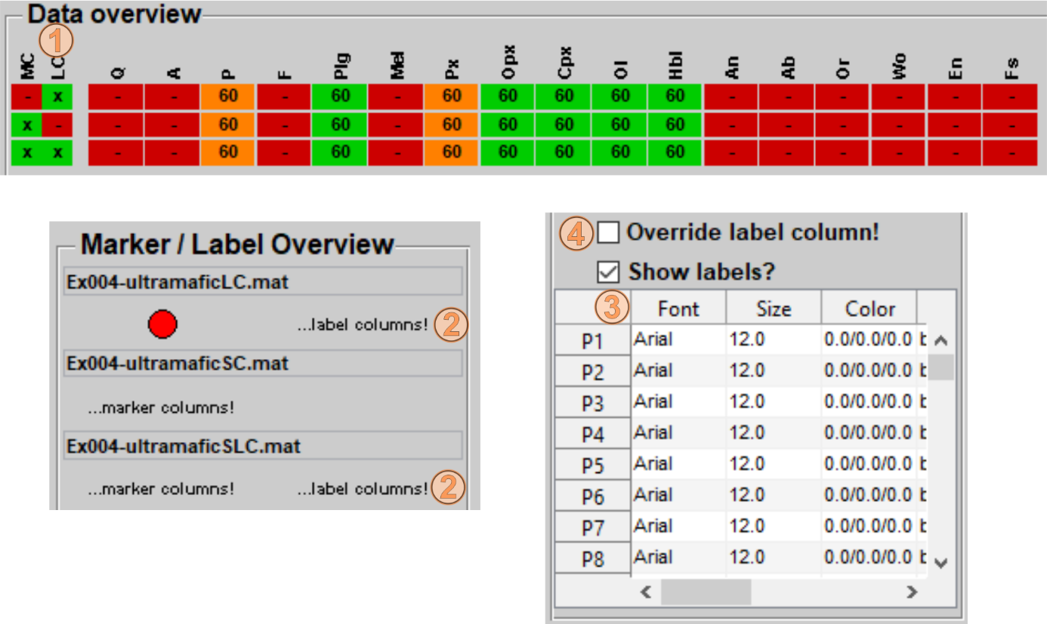

Fig. 9.2‑2: Screenshots of the data overview panel, marker / label overview panel and marker / label setup panels after input datasets contained valid label columns. If correctly defined label columns were present in the input file this will be indicated by the green boxes below the LC header (1). If label columns are active, text is shown instead a label in the marker / label overview panel (2). A table with the label columns (3) will be shown in the marker / label setup panel. The checkbox (4) allows to override the label columns and switch to normal label definition.

# Other Tools

A chemical database is implemented in FastGAPP (FastGAPP20/db/tools/elements_database.m). It contains (I) chemical symbols, (II) full names of the elements, (III) the atomic numbers, (IV) states of the element (solid, liquid, gaseous, radioactive), (V) the molar weights, and (VI) the electro negativities. The tools ‘Chelements’ and ‘PTE’ were developed to quickly display the information from this database.

## Chelements & PTE

In the following screenshot (Fig. 9.2-1) it is shown how to access these two tools. Click on ‘Tools’ in the program selection of FastGAPP’s main window and afterwards click on the buttons ‘Chelements’ and/or ‘PTE’ to start these tools.

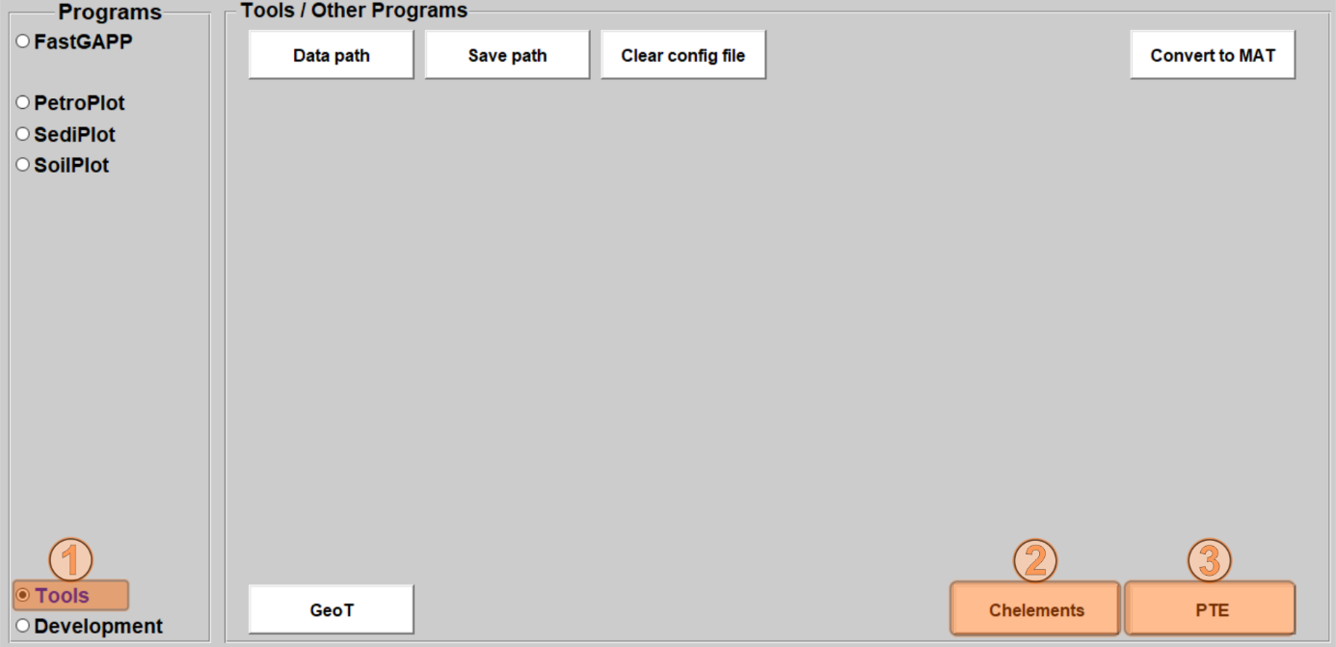

Fig. 10.1‑1: Screenshot to show how to access the tools ‘Chelements’ and ‘PTE’. First, click on ‘Tools’ in the program selection (1) and then start the program by clicking on the ‘Chelements’ or ‘PTE’ buttons (2 & 3).

### Chelements – Usage and Background

After ‘Chelements’ has been started it shows the first entry from the database (Fig. 9.2-2), which is logically hydrogen (atomic number 1). To change the displayed chemical elements, click on the popup menu (1) and click on another element (2).

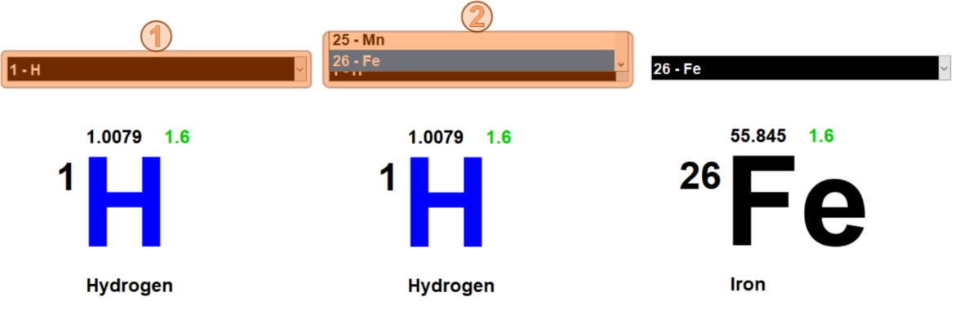

Fig. 10.1‑2: After ‘Chelements’ has been started it shows the first entry from the basic database – hydrogen with the atomic number 1. To change the element to display, click on the popup on top (1) and select other elements (2). Then, the selected element and corresponding information is shown in the ‘Chelements’ user interface.

### PTE – Periodic Table of Elements

No function is included in the ‘PTE’. It simply displays the Periodic Table of Elements (PTE) in a new window. All available information from the database is plotted in this PTE (Fig. 9.1-3).

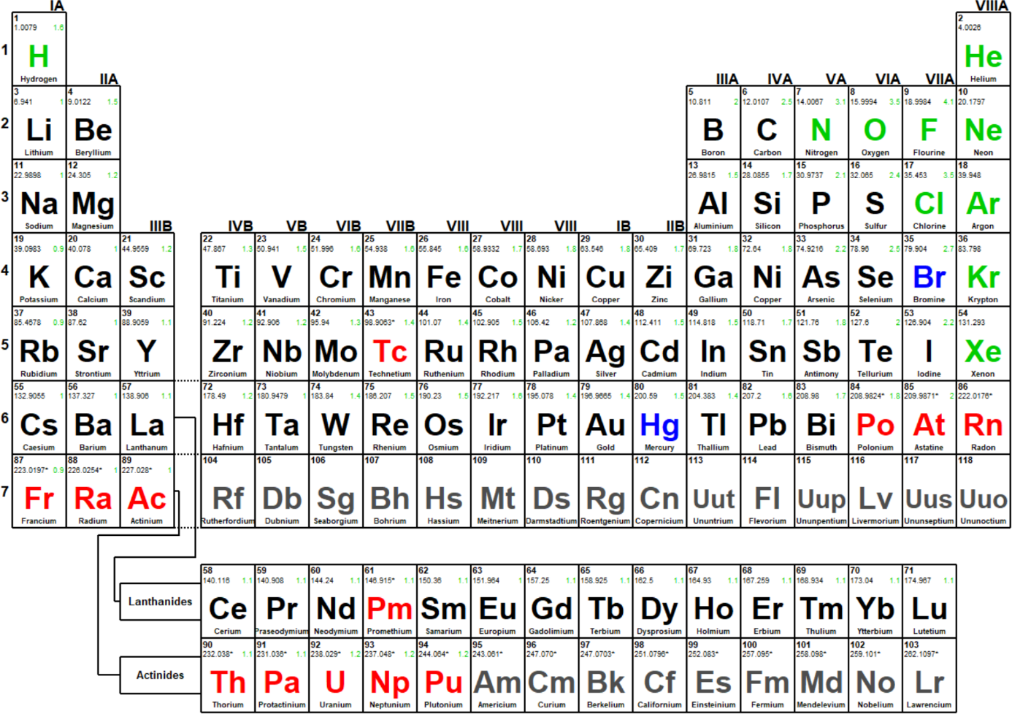

Fig. 10.1‑3: The Periodic Table of Elements created with the tool ‘PTE’.

### Further development information

At some point I wrote a database with several information of all chemical elements. All information is stored in the MATLAB file FASTGAPP20/db/elements_database.m. This function creates a cell array ‘elements’, which contains only the chemical symbol of each element, whereby the position in the cell array represents the atomic number. The structure ‘chem’ contains nested structures for every chemical element, whereby structure names are the chemical symbols and included fields contain (I) again the chemical symbols, (II) complete names of the elements, (III) the atomic numbers, (IV) states of the element (solid, liquid, gaseous, radioactive), (V) the molar weights, and (VI) the electro negativities. The information in the database has no direct geoscientific context. However, the database can be easily extended with more information about the chemical elements, which can then be displayed or used for calculations. Please contact the developer, if you have ideas or wishes regarding these tools.

## GeoT

This tool calculates a simple 1D geothermal gradient in a purely conductive equilibrium (absence of heat advection) from parameters like surface / basal temperature, model (crustal) thickness, thermal diffusivity, and heat production rate. For further information about the calculation and equation used for ‘GeoT’ see Braun et al. (2006).

### How to start and use

The tool ‘GeoT’ can be found in the ‘Tools’ section (Fig. 9.2-1). Click on ‘Tools’ in the program selection and click on the ‘GeoT’ button to start the program. After the ‘GeoT’ is opened (Fig. 9.2-2), parameters of the 1D model can be adjusted by changing the values in the editable fields of the ‘Model Parameters’ panel in the ‘Model parameters’ panel. The results (plotted temperature curve and corresponding table data and the calculated geothermal gradient calculated over different depth) are automatically updated.

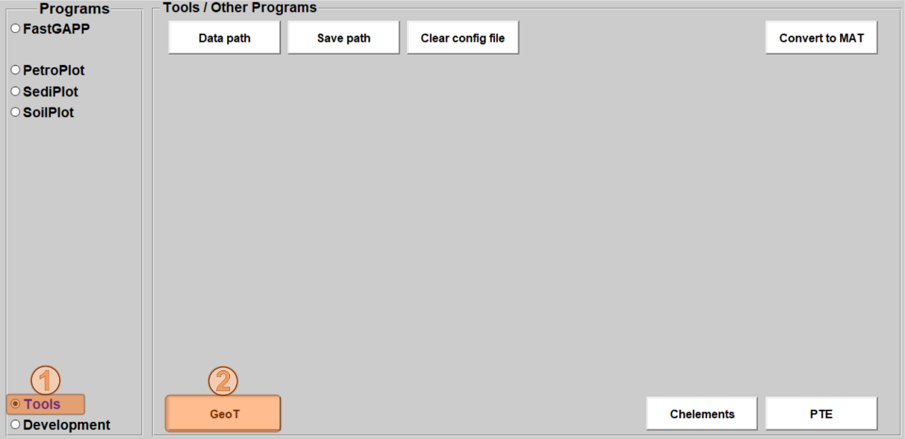

Fig. 10.2‑1: Screenshot to show how to access the tools ‘GeoT. First, click on ‘Tools’ in the program selection (1) and then start the program by clicking on the ‘GeoT’ button (2). The user interface of ‘GeoT’ will open afterwards (see Fig. 9.2-2).

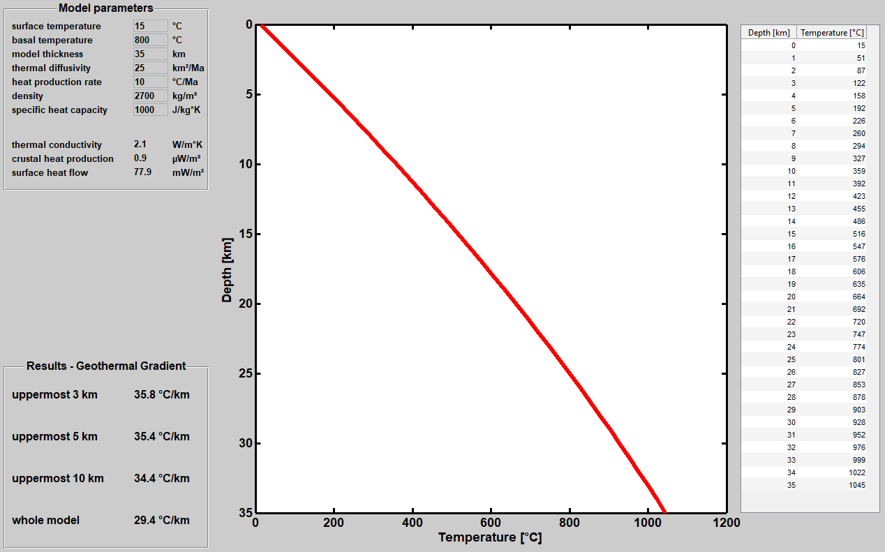

Fig. 10.2‑2: Screenshot of the ‘GeoT’ user interface. Edit the text fields in the ‘Model Parameters’ panel to change parameters of the 1D model. The temperature curve plot and table to the right are automatically updated after changing the model parameters. The resulting geothermal gradient is calculated over different depths of the model and shown at the bottom left ‘Results – Geothermal Gradient’ panel.

### Further information

The tool ‘GeoT’ is a bit more specific than the other tools integrated in FastGAPP. The developer wrote this tool during his master thesis in 2014/15 (Riefstahl, 2015), in which he used the 3D thermo-kinematic code ‘Pecube’ (Braun, 2003) to estimate exhumation rates from low-temperature thermochronological (apatite U-Th-Sm/He and apatite fission) age-elevation relationships along two profiles in the Lepontine Dome, Central European Alps. It is a challenge to estimate any geothermal gradient from the complex 3D model and its numerous parameters (e.g., heat advection, heat production, basal temperature). Therefore, the developer used a simplistic 1D model (Braun et al., 2006) to calculate the geothermal gradient from the best-fitting 3D model parameters. The result was the graphical user interface ‘GeoT’.

# How to create a new sub-program

Three tools were developed to allow users to create user-defined programs, to extent the existing sub-programs with more plots, or to extent the pre-existing database of normalization values. All three tools read information from Excel spreadsheets and translate them into MATLAB code, if these programs are used properly. The three tools can be found by using the ‘Development’ radio button in the program selection panel of FastGAPP’s main window (Fig. 11.0-1).

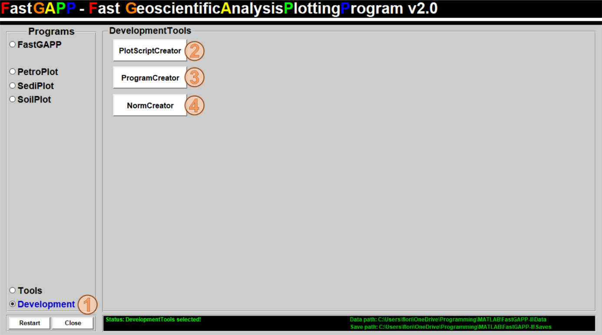

Fig. 10.2‑1: Screenshot of the FastGAPP’s main window after the ‘Development’ tools have been selected by a click on the radio button (1). (2) The ‘PlotScriptCreator’ allows to create the plot and labels. (3) The ‘ProgramCreator’ creates several switch functions captured from the program master excel spreadsheet. (4) The ‘NormCreator’ allows to extent the database with more literature data for the MULTIPLotter contained in FastGAPP.

Three tools are listed, but some prerequisites and knowledge are required to run them. A more or less brief manual on how to handle these development tools is available in the following sections. The developer strongly recommends to create backups of the FastGAPP20 directory before using the development tools!!!

## The PlotScriptCreator

Prerequisites

Users are able to extent the database of plots for the sub-programs or to create plots for a new sub-program by using the ‘PlotScriptCreator’. Properly running the ‘PlotScriptCreator’ requires (i) a specific folder structure, (ii) a master spreadsheet for the program for which the plots and label script will be created and (iii) a spreadsheet for every plot contained in the master spreadsheet.

(i) The directory FastGAPP20/development/ contains the development tools and the two directories normalisation_values and programs (Fig. 11.1-1). The master programs spreadsheet (see section 11.2) and the plot master spreadsheets are stored in the programs directory (Fig. 11.1-1). The programs directory requires to contain a sub-directory for every sub-program (i.e., FastGAPP, PetroPlot, SediPlot, SoilPlot). These program-specific sub-directories require to contain one spreadsheet for every plot in the corresponding sub-program.

(ii) The program-specific plot master spreadsheets (e.g., FastGAPP-Plots.xlsx) are stored in the directory FastGAPP20/development/programs/ (Fig. 11.1-1). All required information about every plot for the sub-programs are stored in the plot master spreadsheets (MASTER_PROGRAMS.xlsx). Users are encouraged to have a look into the plot master spreadsheets to get an idea on how to extent the plot database. The ‘Plots’ sheet of plot master spreadsheets contains information about the input plot spreadsheets, corresponding output m-files, plot and plot axes styles, axes headers and limitations, and references. It is essential to keep the format of the plot master spreadsheets. Errors may occur during the plot script creation process if formats are changed. Replicants of title names and m-file names will lead to conflicts. The ‘headers’ sheet contains information about the valid headers allowed in this program. These can be also easily extended for more headers. The general sheet contains information about the program version, program name, and name of the final directory in FastGAPP20/db/.

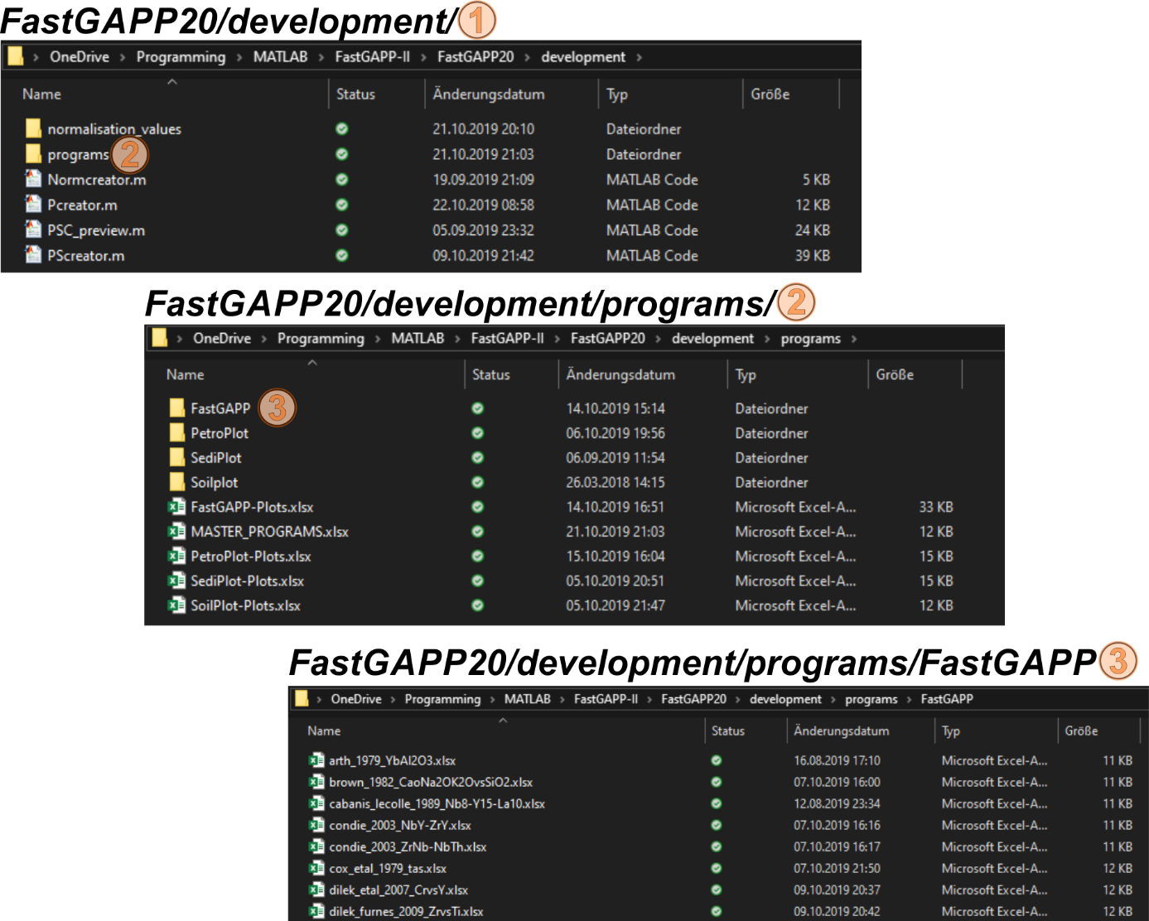

Fig. 11.1‑1: Screenshot of the Windows Explorer illustrating the hierarchal structure of the development directory. The directory FastGAPP20/development/ (1) contains the development tools as m-files and two other directories. The directory FastGAPP20/development/programs/ (2) contains the master program spreadsheet, the plot master spreadsheets and more directories for every program (e.g. FastGAPP). Excel spreadsheets for every plot (3) are located in the program-specific directories (3) (e.g., FastGAPP20/development/programs/FastGAPP/).

(iii) Spreadsheets for the plot lines and plot labels contain three sheets (Fig. 11.1-2). The first sheet ‘general’ has no important function for the creation of the plot scripts but give the user (as well as other users) information about the contents, plot type and headers on each axis. Ideally these should be the same information, which are also listed in the master plot sheet. The lines sheet contains a series of 2‑point line segments with corresponding line type number (Fig. 11.1-2). The label sheet contains the font type number, x- and y-position (center) and rotation of the label.

MATLAB functions created by the PlotScriptCreator

The ‘PlotScriptCreator’ creates several functions, which are stored in the program-specific directories in FastGAPP20/db/ (e.g., FastGAPP20/db/FastGAPP). Generally, two m-files starting with ‘labels_’ and ‘lines_’ are created for every plot spreadsheet listed in the master plot spreadsheet. Among that, the ‘PlotScriptCreator’ writes label and line switches for the sub-program (e.g., fastgapp_labelswitch.m and fastgapp_lineswitch.m). These switches handle the selection from the popups or radio buttons in the main windows (see section 4.7) after any of the button in the ‘Plot Options’ panel (see section 4.8) has been pressed. Furthermore, the control function is written (e.g., fastgapp_control.m), which contains all the information (program name and version, valid header entries, list of plots plus related information, and references). In contrast to the other created functions, the control function is used during the initialization of any sub-program (see Fig. 3.7-1 for further information).

How to run the PlotScriptCreator

After all plot files spreadsheets and the master spreadsheet have been created it is possible to run the ‘PlotScriptCreator’. Start the program by a click on its button (Fig. 11.0-1). A new window opens with a single ‘Load dataset’ button in the options panel. Press this button (Fig. 11.1-3) and a file selection window appears. Select the master plot file of the sub-program for which the plot functions should be created and click on ‘Open’ in the file selection window. After the master plot spreadsheet has been selected, the ‘PlotScriptCreator’ reads all data from it. From the information given in the master plot file the ‘PlotScriptCreator’ continues and reads all listed plot spreadsheets. This may take a while for a larger number of spreadsheets. The user is informed of the progress on the MATLAB command window.

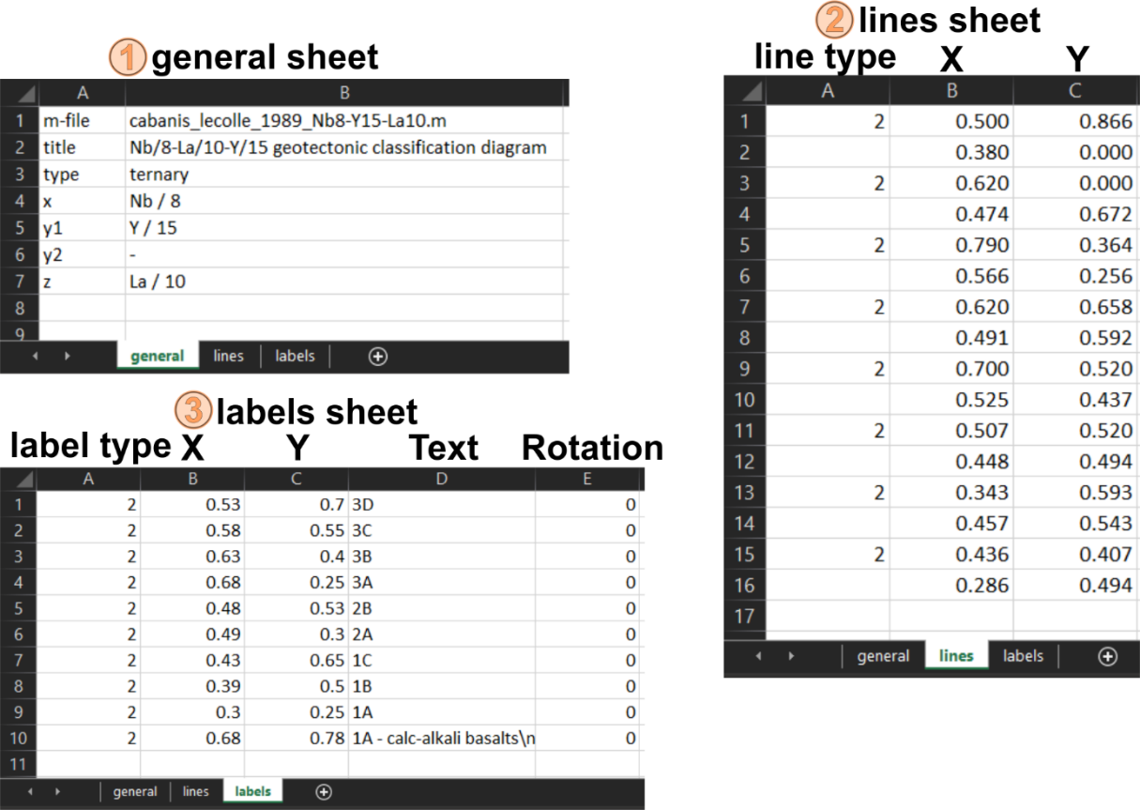

Fig. 11.1‑2: Screenshot of the three sheets in a plot spreadsheet (Shown example is the plot spreadsheet for the ternary Nb/8-La/10-Y/15 geotectonic discrimination diagram after Cabanis & Lecolle, 1989). (1) General information is listed in the general sheet. This are not used while creating the plot functions but give an overview about the content if the plots are shared with other users. (2) The structure lines sheet is simple. It consists of continuously following 2-point line segments in columns B (x-values) and C (y-values). The number in column A at the first entry of each line segment is the line type number, which can be controlled with the line setup panel (see section 4.6). (3) The structure of the labels sheet is also simple. Column A is the font type number, which can be controlled by using the font setup panel (see section 4.6). The x- and y-values in column B and C are the mid-point position of the text. Column D is the text label shown in the plot. Use \n for a new line character. Column E is the rotation of the label.

After all plot spreadsheets have been imported, the ‘PlotScriptCreator’ gives a brief summary in a message box (Fig. 11.1-3). From the developer’s experience, the most frequent error is that the name of any plot spreadsheet does not match those listed in the master plot spreadsheet. In this case, the spreadsheet’s names and spreadsheets listed in the master plot file require corrections. The output on the MATLAB command window may help to troubleshoot. Click the ‘Ok’ button to continue (Fig. 11.1‑3). The main window of the ‘PlotScriptCreator’ now contains another panel entitled ‘Dataset selection’. This panel consists of three tables contains all data from the currently selected plot spreadsheet (see Figs. 11.1-2 and 11.1-3). The first plot dataset will be also shown in the ‘Table Preview’ panel (Fig. 11.1-3). By using the popup in the ‘Dataset selection’ panel the currently shown plot datasets can be switched and proved. The radio buttons ‘Table Mode’ and ‘Preview Mode’ (Fig. 11.1-3) allow to switch from the table mode to the preview of the plot. Note that shown line sizes and font sizes are scaled down. The purpose of the preview is to quickly check adjustment of lines and labels. After the imported plots have been checked, the plot and label functions of the program can be written by clicking on the ‘Create M-file’ button (Fig. 11.2-3). Again, the status messages are printed on the MATLAB command window to inform the user about the progress.

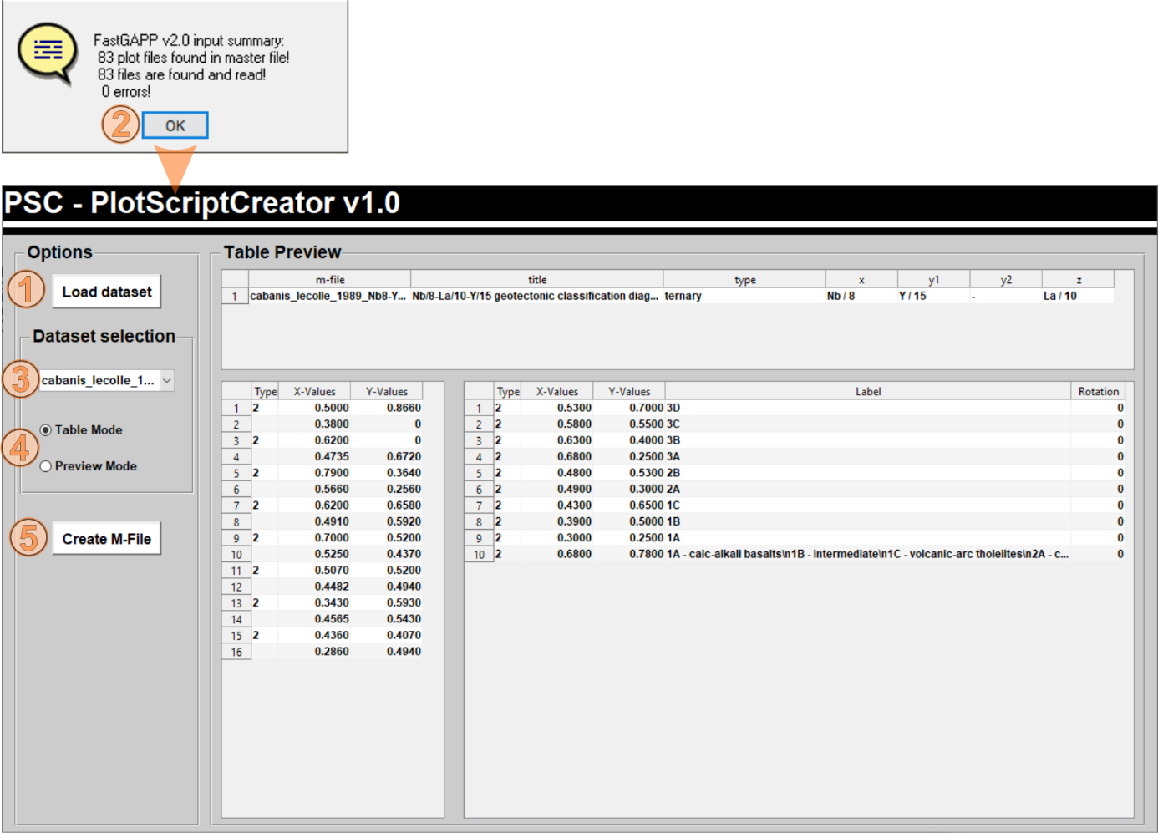

Fig. 11.1‑3: Screenshot of the ‘PlotScriptCreator’ after plots spreadsheets have been loaded. The ‘Load dataset’ button (1) will be present only after starting this development tool. Clicking that button opens a file selection windows where the master plot spreadsheet (e.g., FastGAPP-Plots.xlsx) needs to be selected. After the master plot spreadsheet has been selected, the ‘PlotScriptCreator’ starts to read it and subsequently reads all plot spreadsheet listed in the master plot spreadsheet. Status output will be continuously printed on the MATLAB command window. After all plot spreadsheets have been read, a message dialog box will give a short summary (2) about the input and if all files were found. If errors occurred, check the MATLAB command window for the file or files, which have been not found. Confirm with ‘Ok’ to progress with the ‘PlotScriptCreator’. The ‘PlotScriptCreator’ allows a quick look into the imported plot spreadsheets by using the popup in the ‘Dataset selection’ panel (3). The radio buttons allow to switch between the table and preview mode (4). After the imported plot datasets have been checked, click on the ‘Create m-File’ button (5) to create the plot and label script as well as the switches (see text above for further explanations).

## The ProgramCreator

By using the ‘ProgramCreator’ the user can import the programs master spreadsheet and create required functions and switches for new programs without any MATLAB programming skills. Properly running the ‘ProgramCreator’ requires (i) a specific folder structure and (ii) the program master spreadsheet. Surely, a new program also requires plots (see section 11.1). The program create writes four functions from the master program spreadsheet: (i) program_switch.m, (ii) create_rb_cellar.m, (iii) special_fnc_switch.m, and (iv) start_programs.m. All of these four functions are stored in FastGAPP20/bin/.

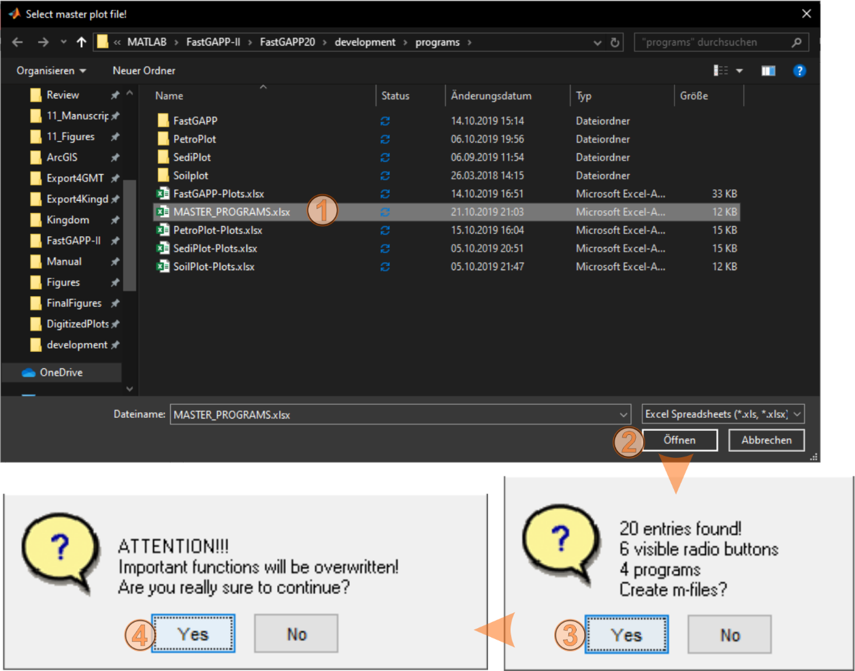

Fig. 11.2‑1: Screenshot of the ‘ProgramCreator’ file selection window and the two following prompts. Select the master program spreadsheet MASTER_PROGRAMS.xlsx in the file selection window (1) after the ‘ProgramCreator’ has been started- Confirmation with ‘Open’ lead to a prompt with some information of the master spreadsheet’s contents. Confirm with ‘Yes’ and another prompt will open and ask if the user is sure to overwrite the function. Agree with ‘Yes’ and the new function will be automatically written. Restart FastGAPP to make the changes visible.

All required information about the sub-programs available in FastGAPP are listed in the master program spreadsheet MASTER_PROGRAMS.xlsx in the directory FastGAPP20/development/. New programs need to be attached in this master spreadsheet. The contents of this file are more or less self-explained. However, it is not allowed to insert new lines or columns in this spreadsheet. Column A is a simple counter; column B is the name of the program; column C is the tool tip string shown if the mouse is located over the corresponding radio button in the program selection panel; column D is the visibility of this radio button (‘On’ and the button will be shown); column E-G are the control function, label / line switches created by the ‘PlotScriptCreator’. If everything went right, these should be the program name in small letters with _control / _lineswitch / _labelswitch following; Column H is the type of main window (mainwindows_type1 or mainwindow_type2); Column I-J gives information about the program-specific function (data handling and recalculation). There is no tool to create the program-specific function, it needs to be self-written. Use ‘none’ for all three fields in beginning.

After the MASTER_PROGRAMS.xlsx has been edited, saved and closed it can be imported by using the ‘ProgramCreator’. Click on the button ‘ProgramCreator’ in the development tools panel (Fig. 11.0-1) to start it. Choose the MASTER_PROGRAMS.xlsx in the new file selection window (Fig. 11.2-1). Afterwards, a prompt shows some statistics about the input and prompts the user to process. Confirm by clicking ‘Yes’ and another prompt asks for another confirmation to proceed. Click another time on ‘Yes’ and the program will write the new functions. Some status output on the MATLAB command window gives information about the progress.

## The NormCreator

The tool ‘NormCreator’ controls the available normalization values available in the MULTIPLotter (see section 5.5) for plotting rare-earth elements or multi-element diagrams. Click on the ‘NormCreator’ button (Fig. 11.0-1) to start the tool. A new file selection window opens already in the directory FastGAPP/development/normalisation_values/. The Excel Spreadsheet normalisation_values.xlsx is located in this directory (Fig. 11.3-1). The content of this spreadsheet (Fig. 11.3-2) can be modified and / or extended for more chemical elements or more normalization values from other publications. While editing this spreadsheet, it is required that the values are given in ppm for all major and trace elements. Note that major elements like K, P, and Ti are not given as oxide in wt.%. Values and text in rows 1-5 should not be modified and the developer does not recommend inserting new rows before row 5 or new columns before column B.

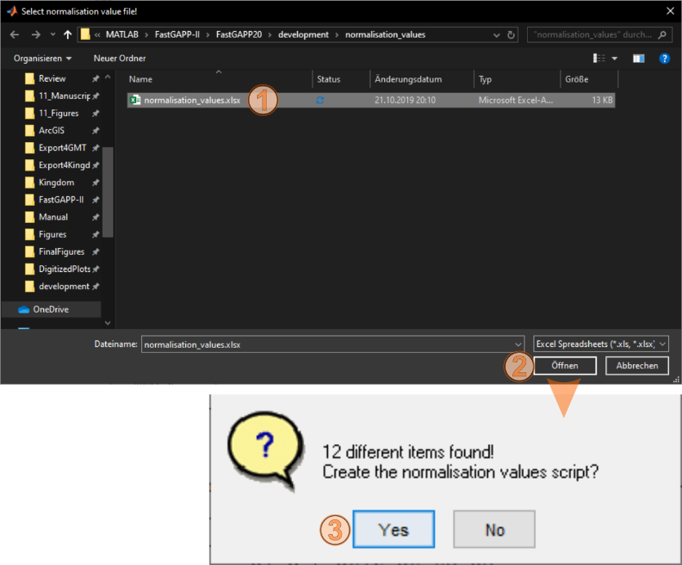

Fig. 11.3‑1: Screenshot after the ‘NormCreator’ has been started. The file selection window will be already in the path where the normalisation_values.xlsx is stored. Select this spreadsheet by a click (1) and confirm with press the ‘Open’ button (2). After the spreadsheet has been imported a dialog box open and prompts the user to proceed. Click on ‘Yes’ and the ‘NormCreator’ writes the new function, which includes the new normalization values.

After the normalisation_values.xlsx spreadsheet has been modified, saved, and closed, it can be selected from the file selection window. (Fig. 11.3-1). The data will be imported and after that a dialog box shows how many items have been found in the spreadsheet and asks to proceed. If agreed with ‘Yes’ the new data will be immediately written in the function normalisation_values.m located in the directory FASTGAPP20/db/normalization/. Some output on the MATLAB command window will show the progress while writing the new function. The new values will be available when the MULTIPLotter will be opened the next time.

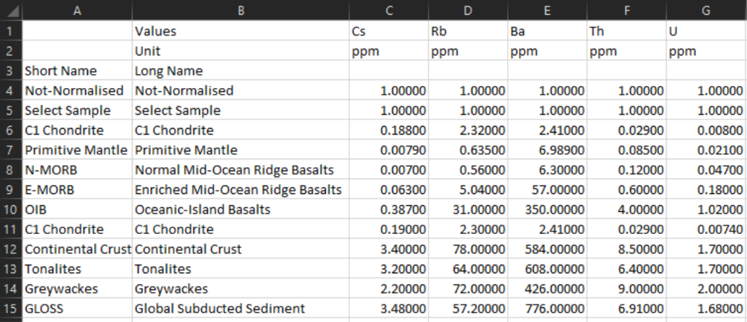

Fig. 11.3‑2: Screenshot of the normalisation_values.xlsx spreadsheet. More lines and more values can be added to the file. However, no new columns should be inserted before column B and no new lines should be inserted before lines 1-5. New normalization values should be also in ppm. Recalculation values (K2O to K, TiO2 to Ti and P2O5 to P) are located below the headers in line 3 (out of view from this screenshot).

# Contact the developer

An alternative approach to create a new program is to [contact the developer](mailto:f.riefstahl@outlook.com?subject=Request%20for%20program%20creation%20or%20adding%20plots) of FastGAPP v2.0.

If the user decides to contact the developer to create a new program or to add more plots, the user is kindly asked to provide or give access to:

(i) The digitized plot datasets in the way these are prepared for the pre-existing sub-programs contained in FastGAPP.

(ii) An updated or new plot master file similar to those already available in FastGAPP. These should contain all necessary information about the plots including references.

The user is also requested to drop some lines about the purpose and target group of the new sub-program to create.

The developer is also interested in new ideas of further development of FastGAPP. If you have any remarks, ideas, comments or corrections (on the program or manual), do not hesitate to contact the developer.

The developer also encourages to report any bugs found while using the program. If any bugs find, please let the developer know the last action and a screenshot of MATLAB error messages. Potentially, the developer will ask for the imported datasets to replicate the bug and rework the code.

Please note: Since the developer also works on other projects some patience is kindly requested. The developer will not digitize any line datasets, collect references or spend overly time into completing the master plot spreadsheet! If all information is available, the developer will integrate the programs and / or new plots in a future version of FastGAPP.

## References

Arth, J.G., 1979. Some Trace Elements in Trondhjemites-Their Implications to Magma Genesis and Paleotectonic Setting, in: BARKER, F.B.T.-D. in P. (Ed.), Trondhjemites, Dacites, and Related Rocks. Elsevier, pp. 123–132. doi:https://doi.org/10.1016/B978-0-444-41765-7.50008-3

Barker, F., 1979. Trondhjemite: Definition, environment, and hypotheses of origin, in: Barker, F. (Ed.), Trondhjemites, Dacites, and Related Rocks. Elsevier, Amsterdam, pp. 1–12.

Braun, J., 2003. Pecube: A new finite-element code to solve the 3D heat transport equation including the effects of a time-varying, finite amplitude surface topography. Comput. Geosci. 29, 787–794. doi:10.1016/S0098-3004(03)00052-9

Braun, J., Van der Beek, P., Batt, G.E., 2006. Quantitative Thermochronology: Numerical Methods for the Interpretation of Thermochronological Data, Time. Cambrige University Press, New York. doi:10.1017/CBO9780511616433

Brown, G.C., 1982. Calc-alkaline intrusive rocks: their diversity, evolution, and relation to volcanic arcs, in: Thorp, R.S. (Ed.), Andesites: Orogenic Andesites and Related Rocks. John Wiley & Sons, New York, 724 pp, pp. 437–461.

Cabanis, B., Lecolle, M., 1989. The La/10-Y/15-Nb/8 diagram - a tool for discriminating volcanic series and evidencing continental-crust magmatic mixtures and/or contamination. Comptes Rendus L’académie Des Sci. Série 2 309, 2023–2029.

Condie, K.C., 2003. Incompatible element ratios in oceanic basalts and komatiites: Tracking deep mantle sources and continental growth rates with time. Geochemistry, Geophys. Geosystems 4, 1–28. doi:10.1029/2002GC000333

Cox, K.G., Bell, J.D., Pankhurst, R.J., 1979. The interpretation of igneous rocks. George Allen and Unwin, London, pp.450.

Dickinson, W.R., Suczek, C.A., 1979. Plate Tectonics and Sandstone Compositions. Am. Assoc. Pet. Geol. Bull. 63, 2164–2182. doi:10.1306/2F9188FB-16CE-11D7-8645000102C1865D

Dilek, Y., Furnes, H., Shallo, M., 2007. Suprasubduction zone ophiolite formation along the periphery of Mesozoic Gondwana. Gondwana Res. 11, 453–475. doi:10.1016/j.gr.2007.01.005

Dott, R.H.J., 1964. Wacke, Graywacke and Matrix--What Approach to Immature Sandstone Classification? SEPM J. Sediment. Res. Vol. 34, 625–632. doi:10.1306/74d71109-2b21-11d7-8648000102c1865d

Eby, G.N., 1992. Chemical subdivision of the A-type granitoids : Petrogenetic and tectonic implications 641–644.

Floyd, P.A., Winchester, J.A., 1975. Magma type and tectonic setting discrimination using immobile elements. Earth Planet. Sci. Lett. 27, 211–218. doi:10.1016/0012-821X(75)90031-X

Folk, R.L., 1965. The Petrology of Sedimentary Rocks. Hemphill Publishing Company.

Folk, R.L., 1954. The distinction between grain size andmineral composition in sedimentary-rock nomenclature. J. Geol. 62, 344–359.

Frost, B.R., Frost, C.D., 2008. A geochemical classification for feldspathic igneous rocks. J. Petrol. 49, 1955–1969. doi:10.1093/petrology/egn054

Gittins, J., Harmer, R.E., 1997. What is ferrocarbonatite? A revised classification. J. African Earth Sci. 25, 159–168.

Gorton, M.P., Schandl, E.S., 2000. FROM CONTINENTS TO ISLAND ARCS: A GEOCHEMICAL INDEX OF TECTONIC SETTING FOR ARC-RELATED AND WITHIN-PLATE FELSIC TO INTERMEDIATE VOLCANIC ROCKS. Can. Mineral. 38, 1065–1073. doi:10.2113/gscanmin.38.5.1065

Hansen, J., Skjerlie, Æ.K.P., Pedersen, Æ.R.B., 2002. Crustal melting in the lower parts of island arcs : an example from the Bremanger Granitoid Complex , west Norwegian Caledonides 316–335. doi:10.1007/s00410-001-0342-5

Hastie, a. R., Kerr, a. C., Pearce, J. a., Mitchell, S.F., 2007. Classification of altered volcanic island arc rocks using immobile trace elements: Development of the Th-Co discrimination diagram. J. Petrol. 48, 2341–2357. doi:10.1093/petrology/egm062

Hollocher, K., Robinson, P., Walsh, E., Roberts, D., 2012. Geochemistry of amphibolite-facies volcanics and gabbros of the støren nappe in extensions west and southwest of Trondheim, Western Gneiss Region, Norway: A key to correlations and paleotectonic settings. Am. J. Sci. 312, 357–416. doi:10.2475/04.2012.01

Ingersoll, R., Suczek, C., 1979. Petrology and provenance of Neogene sand from Nicobar and Bengal fans, DSDP sites 211 and 218. J. Sediment. Petrol. 49, 1217–1228. doi:10.1306/212F78F1-2B24-11D7-8648000102C1865D

Irvine, T.N., Baragar, W.R. a., 1971. A Guide to the Chemical Classification of the Common Volcanic Rocks. Can. J. Earth Sci. 8, 523–548. doi:10.1139/e71-055

Le Bas, M.J., Le Maitre, R.W., Streckeisen, A., Zanettin, B., 1986. A Chemical Classification of Volcanic Rocks Based on the Total Alkali-Silica Diagram. J. … 27, 745–750. doi:10.1093/petrology/27.3.745

Le Bas, M.J., Streckeisen, A.L., 1991. The IUGS systematics of igneous rocks. J. Geol. Soc. London. 148, 825 LP – 833. doi:10.1144/gsjgs.148.5.0825

Le Maitre, R.W., Bateman, P., Dudek, A., Keller, J., Lameyre, J., Le Bas, M.J., Sabine, P.A., Schmid, R., Sorensen, H., Streckeisen, A., 1989. A classification of igneous rocks and glossary of terms. Recommendations of the IUGS Subcommission on the Systematics of Igneous rocks. London Blackwell Sci. Publ.

Macdonald, G., 1968. Composition and origin of Hawaiian lavas. Geol. Soc. Am. Mem 116, 477–522. doi:10.1130/MEM116-p477

McDonough, W.F., Sun, S. -s., 1995. The composition of the Earth. Chem. Geol. 120, 223–253. doi:10.1016/0009-2541(94)00140-4

Meschede, M., 1986. A method of discriminating between different types of mid-ocean ridge basalts and continental tholeiites with the Nb*2-Zr/4-Y diagram. Chem. Geol. 56, 207–218. doi:10.1016/0009-2541(86)90004-5

Middlemost, E.A.K., 1994. Naming materials in the magma/igneous rock system. Earth-Science Rev. 37, 215–224. doi:10.1016/0012-8252(94)90029-9

Miyashiro, A., 1974. Volcanic rock series in island arcs and active continental margins. Am. J. Sci. 274, 321–355. doi:10.2475/ajs.274.4.321

Miyashiro, A., Shido, F., 1975. Tholeiitic and Calc-alkine series in relation to the behaviours of Ti, V, Cr and Ni.

Morimoto, N., 1988. Nomenclature of Pyroxenes. Mineral. Petrol. 39, 55–76. doi:10.1007/BF01226262

Mullen, E.D., 1983. MnO/TiO2/P2O5: a minor element discriminant for basaltic rocks of oceanic environments and its implications for petrogenesis. Earth Planet. Sci. Lett. 62, 53–62. doi:10.1016/0012-821X(83)90070-5

Ntaflos, T., Richter, W., 2003. Geochemical constraints on the origin of the Continental Flood Basalt magmatism in Franz Josef Land, Arctic Russia. Eur. J. Mineral. 15, 649–663. doi:10.1127/0935-1221/2003/0015-0649

Pearce, J. a., Harris, N.B.W., Tindle, A.G., 1984. Trace element discrimination diagrams for the tectonic interpretation of granitic rocks. J. Petrol. 25, 956–983. doi:10.1093/petrology/25.4.956

Pearce, J. a., Norry, M.J., 1979. Petrogenetic implications of Ti, Zr, Y, and Nb variations in volcanic rocks. Contrib. to Mineral. Petrol. 69, 33–47. doi:10.1007/BF00375192

Pearce, J.A., 1983. Role of the sub-continental lithosphere in magma genesis at active continental margins, in: Hawkesworth, C.J., Norry, M.J. (Eds.), Continental Basalts and Mantle Xenoliths. Nantwich, Cheshire, pp. 230–249.

Pearce, J.A., 1982. Trace element characteristics of lavas from destructive plate boundaries, in: Thorpe, R.S. (Ed.), Orogenic Andesites and Related Rocks. John Wiley & Sons, Chichester, England, pp. 528–548.

Pearce, J.A., 1975. Basalt geochemistry used to investigate past tectonic environments on Cyprus. Tectonophysics 25, 41–67. doi:https://doi.org/10.1016/0040-1951(75)90010-4

Pearce, J.A., Alabaster, T., Shelton, A.W., Searle, M.P., Vine, F.J., Smith, A.G., 1981. The Oman ophiolite as a Cretaceous arc-basin complex: evidence and implications. Philos. Trans. R. Soc. London. Ser. A, Math. Phys. Sci. 300, 299–317. doi:10.1098/rsta.1981.0066

Pearce, J.A.J. a., Cann, J.R.R., 1973. Tectonic setting of basic volcanic rocks determined using trace element analyses. Earth Planet. Sci. Lett. 19, 290–300. doi:10.1016/0012-821X(73)90129-5

Pearce, T.H., Gorman, B.E., Birkett, T.C., Sea, R., 1975. Discriminating Between Oceanic and Non-Oceanic Basalts 24, 419–426.

Pearce, T.H.H., Gorman, B.E.E., Birkett, T.C.C., 1977. The relationship between major element chemistry and tectonic envirnment of basic and intermediate volcanic rocks. Earth Planet. Sci. Lett. 36, 121–132. doi:10.1016/0012-821X(77)90193-5

Peccerillo, A., Taylor, S.R., 1976. Geochemistry of eocene calc-alkaline volcanic rocks from the Kastamonu area, Northern Turkey. Contrib. to Mineral. Petrol. 58, 63–81. doi:10.1007/BF00384745

Pettijohn, F.J., 1984. Sedimentary Rocks, 3rd ed. CBS Pulishers and Distributors, New Delhi.

Plank, T., Langmuir, C.H., 1998. The chemical composition of subducting sediment and its consequences for the crust and mantle. Chem. Geol. 145, 325–394. doi:10.1016/S0009-2541(97)00150-2

Riefstahl, F., 2015. Late-stage exhumation history of the Lepontine Dome, Central European Alps: Revelation from low-temperature thermochronology and numerical modelling. University of Bremen.

Riefstahl, F., Estrada, S., Geissler, W.H., Jokat, W., Stein, R., Kämpf, H., Dulski, P., Naumann, R., Spiegel, C., 2013. Provenance and characteristics of rocks from the Yermak Plateau, Arctic Ocean: Petrographic, geochemical and geochronological constraints. Mar. Geol. doi:10.1016/j.margeo.2013.06.009

Shand, S.J., 1943. Eruptive Rocks: their Genesis, Composition, Classification, and their Relation to Ore-Deposits; with a Chapter on Meteorites. John Wiley & Sons, New York.

Shand, S.J., 1927. On the Relations between Silica, Alumina, and the Bases in Eruptive Rocks, considered as a Means of Classification. Geol. Mag. 64, 446. doi:10.1017/S0016756800103760

Shervais, J.W., 1982. Ti-V plots and the petrogenesis of modern and ophiolitic lavas. Earth Planet. Sci. Lett. 59, 101–118. doi:10.1016/0012-821X(82)90120-0

Sun, S. -s., McDonough, W.F., 1989. Chemical and isotopic systematics of oceanic basalts: implications for mantle composition and processes. Geol. Soc. London, Spec. Publ. 42, 313–345. doi:10.1144/GSL.SP.1989.042.01.19

Wedepohl, K.H., 1995. The composition of the continental crust. Geochim. Cosmochim. Acta 59, 1217–1232. doi:10.1016/0016-7037(95)00038-2

Whalen, J.B., Currie, K.L., Chappell, B.W., 1987. A-type granites: geochemical characteristics, discrimination and petrogenesis. Contrib. to Mineral. Petrol. 95, 407–419. doi:10.1007/BF00402202

Winchester, J. a., Floyd, P.A., 1977. Geochemical discrimination of different magma series and their differentiation products using immobile elements. Chem. Geol. 20, 325–343. doi:10.1016/0009-2541(77)90057-2

Wood, D. a., 1980. The application of a Th-Hf-Ta diagram to problems of tectonomagmatic classification and to establishing the nature of crustal contamination of basaltic lavas of the British Tertiary Volcanic Province. Earth Planet. Sci. Lett. 50, 11–30. doi:10.1016/0012-821X(80)90116-8

## Acknowledgements

The developer would like to greatly the working groups of Prof. Dr. Cornelia Spiegel (Geodynamics or the Polar Regions) and Prof. Dr. Wolfgang Bach (Petrology of the Ocean Crust) of the department 5 geosciences of the University of Bremen. The progress and early development of FastGAPP has been presented for these working groups several times. The developer has received some ideas and positive feedback, which has been implemented in FastGAPP v2.0.

Furthermore, the developer wants to thank Boris Priehs for months of helpful MATLAB introductions, instructions and support during the development of the first version of FastGAPP. FastGAPP v2.0 would not be possible without you, Boris!